Discovering the Temporal Evolution of Spatial Spillovers of Green Innovation: An Innovative Approach Using Dynamic Spatial-Temporal Weight Matrices

Zining Wang^{1,2}, Pengyu Zhu^{1,2,}*
¹Division of Public Policy, Hong Kong University of Science and Technology, Hong Kong
² The Center for AI in Economic Social and Environmental Research (CAESER), Hong Kong

*Corresponding Author: Pengyu Zhu
pengyuzhu@ust.hk
Room 4616C, Academic Building, The Hong Kong University of Science and Technology, Clear Water Bay, Kowloon, Hong Kong SAR

Abstract
Understanding how spatial spillovers evolve over time — strengthening, weakening, or reversing — is a fundamental challenge in spatial econometrics, yet most empirical studies rely on static weight matrices that assume time-invariant spatial dependence. This paper proposes a broadly applicable Spatial-Temporal Weight Matrix (STWM) framework in which temporal weights are derived from annual ratios of Moran's I and Geary's C, enabling the matrix to incorporate year-to-year changes in spatial autocorrelation without imposing ad hoc decay assumptions. The temporal and geographic-economic weight structures are integrated via the Kronecker product, and the resulting STWMs are formally shown to satisfy all admissibility conditions for spatial econometric estimation. Exogeneity is confirmed through Hausman tests, and Granger causality tests; finite-sample reliability is validated via Monte Carlo simulation. Applying the framework to green innovation across 276 Chinese cities from 2008 to 2021 reveals strong positive spillovers at the national level alongside substantial spatiotemporal heterogeneity: the Yangtze River Delta has entered the interactive stage, Beijing-Tianjin-Hebei is transitioning from polarization toward diffusion, while the Greater Bay Area, Chengdu-Chongqing, and the Yangtze River Middle Reaches remain in polarization or stalled transitions. A structural break in 2017 further documents a regime shift from inter-city competition to nascent regional synergy in green innovation. The STWM methodology and all associated estimation and validation tools are released as an open-source Python package, providing researchers across disciplines with a replicable and theoretically grounded instrument for analyzing dynamic spatial dependence in any panel setting.

Keywords: Green development; Spatial-temporal weight matrix; Urban growth pole theory

Introduction
As global economies navigate technological advancement and ecological sustainability, green innovation has emerged as a central object of inquiry in regional science and environmental economics. Understanding how green innovation spreads across space—and how that spread evolves over time—is critical for designing policies that harness agglomeration benefits while ensuring peripheral regions are not permanently left behind. Growth Pole Theory, originally proposed by Perroux (1950) and extended by Myrdal (1957), Hirschman (1958), and Boudeville (1966), predicts that spatial spillovers between core and peripheral cities evolve through three qualitatively distinct stages: polarization, diffusion, and interactive. Each stage is governed by a distinct spatial dependence structure—unidirectional attraction, unidirectional diffusion, and bidirectional exchange respectively—making green innovation a theoretically compelling domain in which to examine how these dynamics manifest and transition.
Spatial econometrics is the standard toolkit for modeling spillover processes, with spatial weight matrices (SWMs) serving as the foundation for capturing inter-city dependence (LeSage & Pace, 2009). However, all conventional SWMs are temporally invariant: a single weight matrix is imposed on every time period of the panel. This assumption directly contradicts Growth Pole Theory's central prediction that spatial dependence undergoes qualitative transitions across developmental stages. Estimated over a multi-year panel, a static SWM conflates polarization, diffusion, and interaction dynamics into a single time-averaged parameter, masking precisely the stage-specific mechanisms that theory predicts (Gao et al., 2019). The few existing spatiotemporal weight matrices (STWMs) address this only partially — relying on arbitrary temporal windows, exogenously fixed decay parameters, or endogenous specifications — without grounding the temporal component in observed data on how spatial relationships actually evolve (Smith & Wu, 2009; Dubé et al., 2014; Chen et al., 2021).
This paper addresses this gap by proposing a family of exogenous spatiotemporal weight matrices (STWMs) whose temporal weights adapt dynamically to empirical shifts in spatial dependence using observed spatial autocorrelation coefficients, avoiding arbitrary functional forms. China provides an ideal empirical laboratory for this framework, as its regional development and green innovation trajectories perfectly mirror the polarization, diffusion, and interactive stages of Growth Pole Theory(Deng, 1978; Démurger et al., 2002). Specifically, early green R&D concentrated heavily in coastal hubs (polarization), subsequently spread inland driven by environmental policies (diffusion), and is now fostering collaborative innovation across urban clusters (interaction). Consequently, our 14-year panel of 276 cities captures these three heterogeneous stages unfolding simultaneously. This complex spatiotemporal dynamic exposes the inadequacy of static spatial weight matrices and highlights the analytical value of our STWM framework's temporal sensitivity (Figure 1).
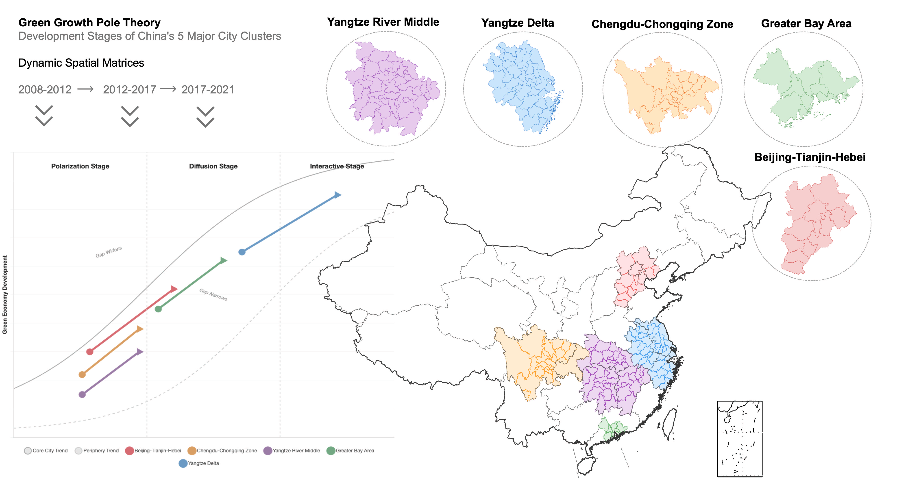
Figure 1 Dynamic stages of Green Growth Pole Theory and the spatial distribution of China’s five major urban clusters.

To facilitate replication and broader adoption, the proposed STWM framework is implemented as an open-source Python package (stwm), available at https://github.com/ZiningPe/STWM. The package provides end-to-end functionality for constructing TWMs from four temporal statistics (Moran's I, Geary's C, Getis-Ord G, and Spatial Gini), assembling the full STWM via the Kronecker product, and estimating all standard spatial models — spatial lag of X (SLX), spatial autoregressive (SAR), spatial error (SEM), and spatial Durbin (SDM) — with panel fixed and random effects. A complete suite of validation and robustness tools is included—covering exogeneity tests, heteroskedasticity diagnostics, rolling-window estimation, and Monte Carlo validation—enabling researchers to assess the credibility and stability of their STWM-based estimates without additional programming overhead.
The remainder of this article is structured as follows. The following section reviews Growth Pole Theory and the development and limitations of spatial weight matrices, with particular attention to the time-invariance problem and existing attempts at temporal extension. The third section details the construction process of the STWMs. The fourth section presents an example of applying STWMs in spatial regression. The final section concludes the study.

Literature Review

Growth Pole Theory: Mechanisms, Stages, and Spatial Implications
The spatial evolution of regional systems is driven by the shifting balance between centripetal and centrifugal forces. During the initial polarization phase, agglomeration economies trigger cumulative causation that establishes asymmetric, extractive spatial dependence: core regions drain resources from the periphery, widening regional inequality (Marshall, 1890; Krugman, 1991). As congestion diseconomies eventually outweigh agglomeration benefits, centrifugal forces initiate the diffusion phase, in which outward positive spillovers—technology transfer and firm relocation—are facilitated by geographic proximity and the periphery's growing absorptive capacity (Audretsch & Feldman, 2004). The process culminates in an interactive phase characterized by symmetric spatial dependence, where core and peripheral cities sustain bidirectional knowledge exchange within a converged, polycentric network (Cooke & Morgan, 1998).
Empirical applications across diverse contexts—from European regional convergence (Geppert et al., 2008) to industrial evolution in emerging economies (Yusuf & Nabeshima, 2005)—confirm that spatial spillovers follow dynamic trajectories. The unifying theoretical insight is that spatial dependence is not a fixed structural parameter but an evolving relationship dictated by developmental stage, carrying a direct methodological implication: frameworks imposing a time-invariant SWM are inherently misspecified when applied to panels spanning multiple Growth Pole phases. Green innovation is particularly susceptible to these stage-dependent dynamics: its high R&D intensity and dependence on institutional support initially concentrate innovative capacity in first-tier cities, generating strong polarization (Rastogi, 2023), while the non-rival and transmissible nature of green knowledge subsequently enables diffusion once peripheral cities develop sufficient absorptive capacity (Audretsch & Feldman, 2004).

Spatial Weight Matrices: Development and Limitations
Spatial econometrics addresses cross-sectional interdependence through SWMs that formalize inter-unit dependence, enabling consistent estimation of spatial autoregressive models (Anselin, 1988; Elhorst, 2014; LeSage & Pace, 2009). SWM development has proceeded through three broad generations: geometry-based matrices relying on binary contiguity—Rook, Bishop, and Queen adjacency rules—or derived forms such as k-nearest neighbor matrices; continuous distance-based matrices employing power, inverse, polynomial, and exponential decay functions (Dubin, 1998; Kelejian et al., 2012); and economic and social scale matrices incorporating per capita GDP differentials, migration, and population movement (Paelinck, 1978; Zhang et al., 2019). Nested SWMs combine multiple specifications to capture the multidimensional nature of spatial interaction (LeSage & Ha, 2012; Fingleton & Le Gallo, 2008).
Despite this progress, all SWMs share a fundamental limitation: temporal invariance. This is innocuous in short panels with stable spatial structures, but becomes a substantive source of misspecification in long panels covering structural transformation—precisely the conditions under which Growth Pole Theory predicts qualitative shifts in spatial dependence. By averaging across polarization, diffusion, and interaction regimes, temporally invariant SWMs produce estimates that accurately reflect none of these stages and may yield biased indirect effect estimates (Dubé et al., 2014).
A small but growing literature has proposed STWMs to address this. Smith & Wu (2009) introduce binary STWMs within specified spatiotemporal influence windows, but impose an arbitrary temporal cutoff. Dubé et al. (2014) compute STWMs from Euclidean distances in three-dimensional space-time, though constraining same-region observations across periods to receive zero weight may misrepresent within-region path dependence. Chen et al. (2021) combine an exponential temporal decay function with a geographic SWM via the Kronecker product, but fix the decay parameter exogenously. Liu et al. (2022) adopt a similar approach with alternative decay specifications. These contributions confirm that temporal variation improves model performance, yet two gaps remain: all existing STWMs rely on arbitrary or endogenous specifications that do not exploit observed spatial relationships across periods, and none is grounded in a dynamic theory of evolving spatial dependence, leaving them unable to distinguish polarization- from diffusion-dominated periods (Fan & Hudson, 2018).
This study responds by constructing exogenous STWMs leveraging spatial autocorrelation coefficients across time periods, offering a more robust framework for understanding the dynamic spillover effects of green innovation across regions.

Theoretical Foundations and Constructing STWM
To fill the research gap on STWMs, this study proposes a three-step construction procedure: first establishing a geographically and economically nested spatial weight matrix (SWM); second deriving a temporal weight matrix (TWM) from the year-by-year trajectory of Moran's I and Geary's C; and third combining both components via the Kronecker product to obtain the STWM. The resulting matrices are then applied to spatial regression models to capture both the cross-sectional structure of spillovers and their temporal transmission dynamics.
Establishment of the Initial Spatial Weight Matrix (SWM)
Constructing SWMs requires examining the pathways through which spatial spillover effects occur between regions. To build a spatial economic distance matrix, this study combines geographic distance weights and economic distance weights, capturing both spatial proximity and economic relationships (Parent & LeSage, 2008):
$$\begin{aligned}W_{ij}=\left\{\begin{aligned}\frac{1}{\left|{perGDP}_{i}-{perGDP}_{j}\right|d_{ij}}, &i≠j \\ 0 , &i=j\end{aligned}\right.\#\left(1\right)\end{aligned}$$
where ${perGDP}_{i}$ and ${perGDP}_{j}$ represent city $i$’s and city $j$’s per capita GDP, respectively. $d_{ij}=arcos[\left(sinΦ_{i}×sinΦ_{j}\right)+\left(cosΦ_{i}×cosΦ_{j}×cosΔτ\right)]×R$ denotes the geographic distance between city $i$ and $j$. $Φ_{i}$ and $Φ_{j}$ measures of the parallel of latitude of the cities. $Δτ$ represents longitude difference between cities. R denotes the earth radius. All SWMs require standardization, and the main methods include Row standardization, Column standardization, Row-element non-standardization (Leenders, 2002), and Eigenvalue-based standardization (Corrado & Fingleton, 2012). This study adopts the widely used row standardization, specifically ${SWM}_{ij}={W_{ij}}/{\sum_{j=1}^{n}{W_{ij}}}$ to derive the SWM matrix as follow:
$$\begin{aligned}SWM= \left[\begin{matrix}0 & {SWM}_{12} & ⋯ & {SWM}_{1n} \\ {SWM}_{21} & 0 & ⋯ & {SWM}_{2n} \\ ⋮ & ⋮ & ⋱ & ⋮ \\ {SWM}_{n1} & {SWM}_{n2} & ⋯ & 0\end{matrix}\right]\#\left(2\right)\end{aligned}$$

Establishment of Temporal Weight Matrix (TWM)
The TWM quantifies how strongly the spatial spillover intensity of one period transmits to subsequent periods. Following Shahnazi & Dehghan Shabani (2021), we compute Moran's I and Geary's C for each year $l$:$\begin{aligned} I_{l}=\frac{n\sum_{i=1}^{n}{\sum_{j=1}^{n}{{SWM}_{ij}\left(Y_{i}-\overline{Y}\right)\left(Y_{j}-\overline{Y}\right)}}}{\sum_{i=1}^{n}{\sum_{j=1}^{n}{{SWM}_{ij}}}\sum_{i=1}^{n}{{\left(Y_{i}-\overline{Y}\right)}^{2}}}\#\left(3\right)\end{aligned}$
$\begin{aligned}C_{l}=\frac{\left(n-1\right)\sum_{i=1}^{n}{\sum_{j=1}^{n}{{SWM}_{ij}{\left(Y_{i}-Y_{j}\right)}^{2}}}}{2\sum_{i=1}^{n}{\sum_{j=1}^{n}{{SWM}_{ij}}}\sum_{i=1}^{n}{{\left(Y_{i}-\overline{Y}\right)}^{2}}}\#\left(4\right)\end{aligned}$
where $Y_{i}$ represents the dependent variable of city $i$, and $n$ denotes the number of cities.
The off-diagonal entries of the TWM are defined as the ratio of autocorrelation statistics across periods:$\begin{aligned}T_{I}=\left[\begin{matrix}1 & 0 & ⋯ & 0 \\ {I_{2}}/{I_{1}} & 1 & ⋯ & 0 \\ ⋮ & ⋮ & ⋱ & ⋮ \\ {I_{t}}/{I_{1}} & {I_{t}}/{I_{2}} & ⋯ & 1\end{matrix}\right]; T_{C}=\left[\begin{matrix}1 & 0 & ⋯ & 0 \\ {C_{2}}/{C_{1}} & 1 & ⋯ & 0 \\ ⋮ & ⋮ & ⋱ & ⋮ \\ {C_{t}}/{C_{1}} & {C_{t}}/{C_{2}} & ⋯ & 1\end{matrix}\right]\#\left(5\right)\end{aligned}$
Three structural features of this construction warrant emphasis. First, the main diagonal is set to unity because the spillover effect within the same period has unit transmission strength. Second, all upper-triangular entries are zero, encoding the causal constraint that future periods cannot influence past ones. Third, row standardization is applied to both $T_{I}$and $T_{C}$, yielding valid stochastic matrices ${\text{TWM}}_{I}$ and ${\text{TWM}}_{C}$.
The ratio ${\text{TWM}}_{ts}=a_{t}/a_{s}$has a natural economic interpretation: it measures the relative intensity of spatial clustering at time $t$compared to time $s$. When clustering is intensifying — as during the diffusion stage of Growth Pole Theory — ratios for more recent periods exceed unity, assigning higher temporal weights to recent transmission channels. When clustering weakens, ratios fall below unity, down-weighting distant-period transmission accordingly. This structure is more economically defensible than an arbitrary exponential decay, which assumes monotone decline regardless of the actual clustering trajectory.
To ensure numerical stability when the autocorrelation statistic approaches zero or changes sign, two safeguards are applied prior to row standardization: a minimum absolute value of ${10}^{-3}$ is imposed on the denominator, and off-diagonal entries are winsorized at the 95th percentile to prevent extreme ratios from dominating. Sensitivity analysis over a $3×3$ hyperparameter grid (winsorize quantile $∈\{0.90,0.95,0.99\}$, minimum absolute value $∈\{{10}^{-4},{10}^{-3},{10}^{-2}\}$) confirms robustness: all coefficient of variation values across the nine resulting specifications remain below 0.005, well under the 0.05 stability threshold (Table B1).
Establishment of Spatial-Temporal Weight Matrices (STWMs)
The SWM and TWM are combined via the Kronecker product, STWM=TWM⊗SWM, as illustrated in Figure 2. This construction is not merely a computational convenience — it carries formal admissibility guarantees
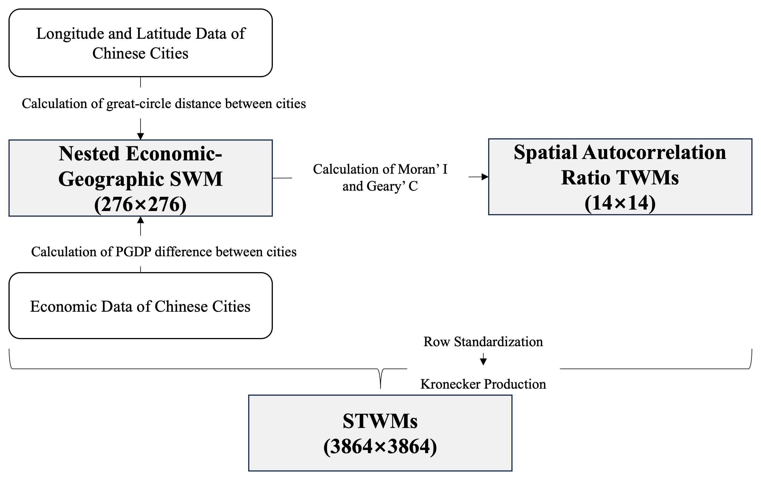
Figure 2. The process of spatial-temporal weight matrix (STWM) construction.

Theorem 1 (Admissibility). $\text{TWM}$ is a row-stochastic, non-negative, lower-triangular matrix with unit diagonal, and $\text{SWM}$ is a row-standardized spatial weight matrix with zero diagonal. Then $\text{STWM}=\text{TWM}⊗\text{SWM}$ satisfies all admissibility conditions for spatial econometric estimation:
(A1) Non-negativity: $STWM_{pq}$≥ 0 for all p, q.
(A2) Zero diagonal: $STWM_{pp}$ = 0 for all p.
(A3) Row-stochasticity: ST$WMι_{N}=ι_{N}$.
(A4) Bounded spectral radius: ρ(STWM) ≤ 1.
By the mixed-product property of Kronecker products, the eigenvalues of $\text{STWM }$are $\{μ_{j}λ_{k}\}$where $μ_{j}$and $λ_{k}$ are eigenvalues of $\text{TWM }$and $\text{SWM }$respectively, so $ρ(\text{STWM})≤ρ(\text{TWM})⋅ρ(\text{SWM})≤1$. Properties (A1)–(A3) follow directly from the non-negativity and row-stochasticity of both component matrices.
Each element of the resulting matrix,
$$\begin{aligned}STWM\left[\left(t,i\right),\left(s,j\right)\right]=TWM\left[t,s\right]×SWM\left[i,j\right]\#\left(6\right)\end{aligned}$$
represents the composite transmission weight from city $j$at time $s$to city $i$at time $t$— the product of how strongly period $s$informs period $t$and how spatially proximate city $j$is to city $i$. Appendix B provides a numerical illustration for $T=3$, $n=4$(Table B2).

Application of the STWM in Green Innovation Analysis
Green innovation is selected as the empirical application because its dual externalities — environmental public goods combined with private R&D costs — make spatial spillover dynamics both theoretically predicted and policy-relevant, providing a demanding test case for the STWM framework (Fagerberg et al., 2010; Wang & Zhu, 2020; Becker et al., 2023; Nordhaus, 2021; Kolstad, 2011).

Data and Variables
Dependent variable: Green Innovation(Y). This study adopts the definition proposed by Cisneros Chavira et al. (2023) and Kemp & Pontoglio (2011), describing green innovation as a product, process, service, or management method that is novel to the implementing firm and reduces environmental risk, pollution, and negative resource impacts compared to relevant alternatives throughout its life cycle. The literature identifies two primary measurement approaches: evaluating performance based on inputs, desired outputs, and undesired outputs; and counting green patents (Shan & Shao, 2024; Xu et al., 2021). This study measures green innovation at the city level by counting granted green patents (Fankhauser et al., 2013; Liu et al., 2022; Zhang et al., 2020), identified by matching IPC classification numbers against the World Intellectual Property Organization's Green List.

Core Variables. Based on prior research (Liu et al., 2022; J. Zhang et al., 2020), the following variables are included:
Industrial Structure (Indus): Share of the secondary sector in GDP. A higher share typically steers innovation toward resource-intensive activities, potentially hindering green innovation.
Consumption Level (Cons): Total retail sales of consumer goods. Rising consumption drives demand for green products, incentivizing green innovation.
Income Level and Labor Costs (Wage): Average wage of urban employees. Higher wages attract skilled professionals, enhancing green innovation capacity.
Human Resources and Education (Pop and Edu): Government expenditure on education and total city population. Investment in education cultivates the workforce capacity essential for sustained innovation.
Technological Investment (Tech): Government expenditure on science and technology. Direct public R&D investment supports green technological advancement.
Infrastructure Development (Inf): Road freight volume, measuring economic activity intensity and the efficiency of knowledge and goods flows.
The dependent variable and log-skewed regressors (Cons, Wage, Edu, Pop, Tech, Inf) are log-transformed. Descriptive statistics are reported in Table 1.

Table 1 Descriptive Statistics of the Dependent and Independent Variables
Variable | N | Mean | SD | Min | Max
Y | 3864 | 4.216 | 1.782 | 0 | 9.872
Wage | 3864 | 10.73 | 0.341 | 10.09 | 11.23
Pop | 3864 | 5.913 | 0.0190 | 5.872 | 5.937
Inf | 3864 | 9.341 | 0.243 | 8.766 | 9.545
Tech | 3864 | 10.26 | 0.533 | 9.174 | 10.90
Edu | 3864 | 12.99 | 0.438 | 12.10 | 13.48
Cons | 3864 | 15.49 | 1.072 | 5.476 | 19.01
Indus | 3864 | 46.47 | 10.86 | 10.68 | 85.08

The empirical analysis is based on a balanced panel of 276 Chinese cities observed annually from 2008 to 2021. Green patent data are sourced from the China Intellectual Property Office, with additional data from the China Statistical Yearbooks, China Population and Employment Statistical Yearbooks, China Energy Statistical Yearbooks, and China Science and Technology Statistical Yearbooks.
Spatial Model Specification
The spatial spillover effects of green innovation are influenced by industrial structure, level of economic development, energy structure, and human resources (Becker et al., 2023). This study specifies three candidate spatial models:
$$\begin{aligned}Y=α+ρSTWMY+βX+ε\#\left(7.1\right)\end{aligned}$$
$$\begin{aligned}Y=α+βX+ε, ε=ρSTWMε+θ\#\left(7.2\right)\end{aligned}$$
$$\begin{aligned}Y=α+ρSTWMY+βX+δSTWMX+ε\#\left(7.3\right)\end{aligned}$$
where Y is the green innovation and X is a series of explanatory variables that may affect the green innovation. STWM is the spatial-temporal weight matrix divided into two matrices constructed based on Moran’s I, $S{TWM}_{I}$and Geary’ C, S${TWM}_{C}$. $α$ denotes the constant and $ε$ is the error term.
Validity and Identification
Exogeneity of the temporal weights. A potential concern is that deriving the STWM from the dependent variable's spatial autocorrelation trajectory might introduce endogeneity. Following Cheng & Lee (2017) and Zhu et al. (2022), we address this via a Hausman test using the inverse geographic distance matrix $W_{g}$ as an exogenous benchmark (Figure 3). In the model $Y=α+ρ(WY)+σX+ε$, the term $WY$ is potentially endogenous. We instrument it first with $W_{g}X$(exogenous benchmark) and then with STWM*X, and test whether the two sets of estimates differ systematically. Failure to reject the null implies STWM is exogenous. The Hausman statistics for ST${WM}_{I}$ and ST${WM}_{C}$ are$-14.294$and$-13.140$respectively, since a negative value arises only when the estimated covariance difference fails to be positive semi-definite in finite samples, it is conventionally read as failure to reject the null of exogeneity (Baltagi, 2021; Zhu et al., 2022).
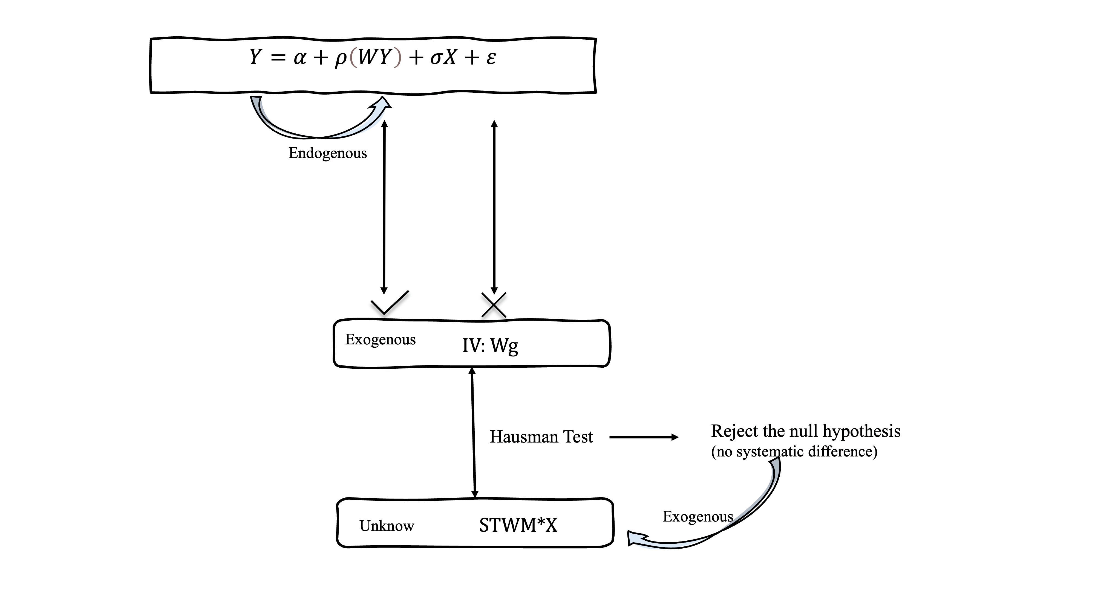
Figure 3 Hausman test framework for assessing the exogeneity of the STWM.

Absence of circular identification. A second concern is that the weighting structure might mechanically drive the estimated spillover effects. We test this via Granger causality, examining whether the temporal evolution of the weighting metric predicts changes in the estimated indirect spillover effects. As shown in Table 2, F-statistics for lags 1–3 are statistically insignificant (p>0.10) for both Moran's I and Geary's C. Non-rejection of the null confirms that the STWM captures exogenous variation in spatial clustering intensity rather than a circular artifact of the dependent variable.
Table 2 Granger causality test
Dependent Variable | Lag | F-Statistic | p-value
Panel A: Moran's I
 | 1 | 0.0508 | 0.8282
 | 2 | 0.9709 | 0.4532
 | 3 | 1.1051 | 0.5884
Panel B: Geary's C
 | 1 | 0.1606 | 0.7006
 | 2 | 2.3750 | 0.2090
 | 3 | 30.8028 | 0.1315
Note: H₀: no Granger causality.

Superiority over static SWM. Table 3 compares model fit between the static SWM and the proposed STWM. The Adjusted R² increases from 0.3486 to 0.3842, while AIC and BIC fall by 217 and 217 points respectively — improvements of a magnitude that indicates decisive specification gains in spatial econometrics. The redundancy test (F=44.173, p < 0.001) rejects the null that the temporal weight components provide no incremental explanatory power, confirming that ignoring the temporal evolution of spillovers constitutes model misspecification.
Table 3 Model Fit Comparison and Redundancy Test
Metric | SWM | STWM
R² | 0.3500 | 0.3855
Adjusted R² | 0.3486 | 0.3842
AIC | 2816.08 | 2598.87
BIC | 2866.16 | 2648.94
Redundancy F | - | 44.173 (p < 0.001)

Testing Spatial Autocorrelation and Model Selection
Figure 4 plots Moran's I and Geary's C for green innovation across the 276 cities from 2008 to 2021. Moran's I is positive and significant at the 1 percent level throughout, ranging from 0.149 (2014) to 0.204 (2020). Geary's C remains consistently below 1 (0.644–0.684), significant at the 1 percent level, corroborating the presence of positive spatial autocorrelation. These results confirm that spatial dependence is a persistent feature of green innovation and that spatial modeling is warranted.
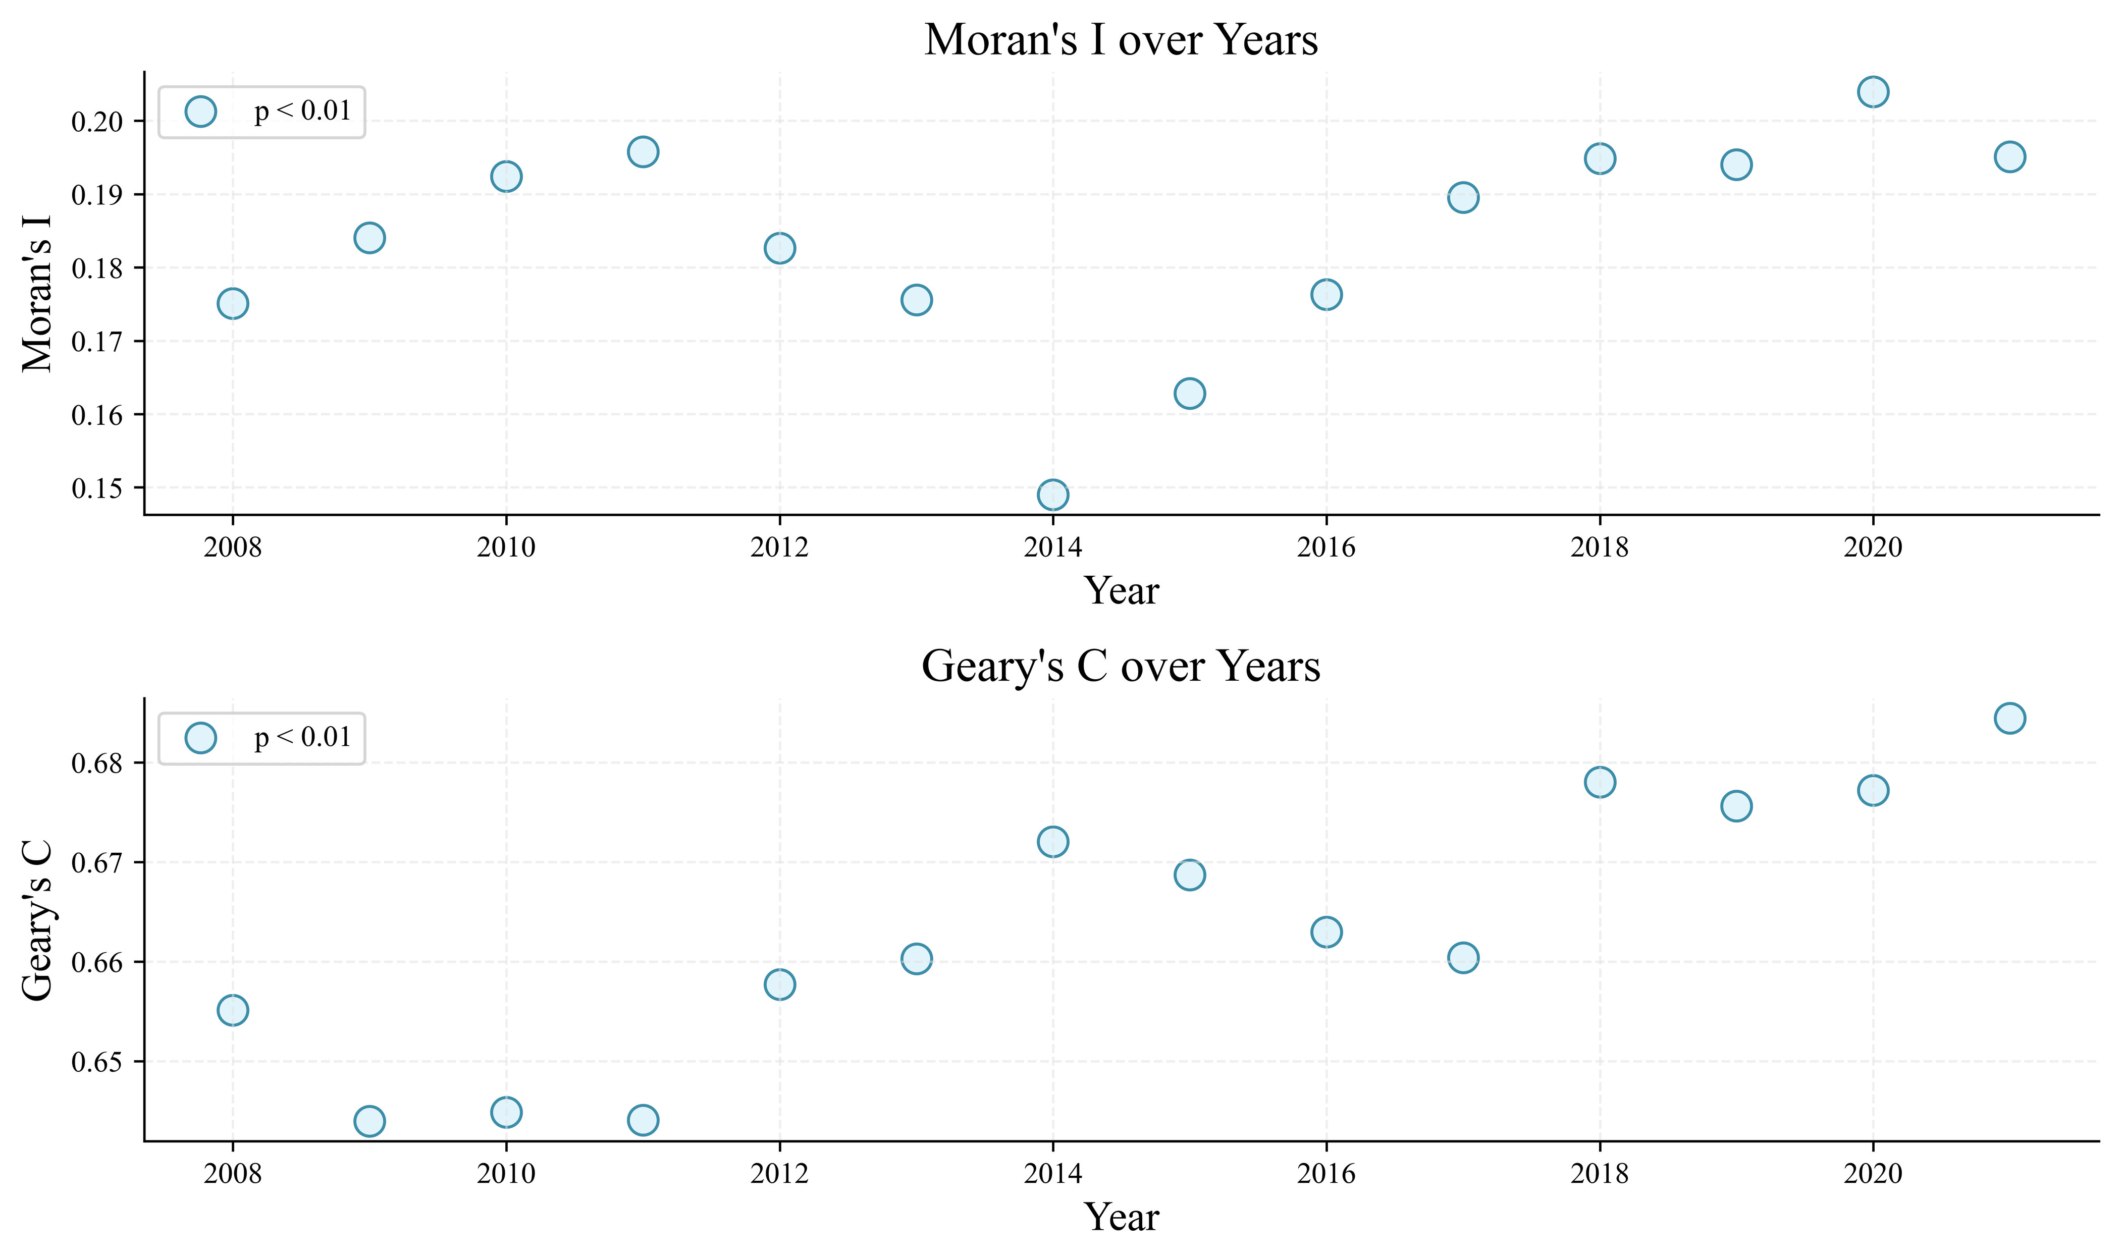
Figure 4 Spatial autocorrelation test of green innovation across 276 Chinese cities, 2008–2021.

To select among the SAR, SEM, and SDM specifications, Table 4 reports Lagrange Multiplier tests following Anselin et al. (2006).

Table 4.Diagnostic Test Results for Weight Matrices
Model specification | LM -lag | Robust LM-lag | LM-error | Robust  LM-error | LM-SARMA | Joint test for SDM
Weight matrix: SWM
 | 0.408 | 0.402 | 0.009 | 0.003 | 0.411 | 4.180
Weight matrix: STWM_I
 | 232.004*** | 154.563*** | 143.838*** | 66.396*** | 298.400*** | 504.970***
Weight matrix: STWM_C
 | 235.072*** | 154.324*** | 151.711*** | 70.962*** | 306.034*** | 511.963***
Note: *, **, and *** represent significance at the level of 10 %, 5 % and 1 %, respectively.

The static SWM produces uniformly non-significant test statistics, confirming that a time-invariant weight matrix fails to detect the spatial dependence present in the data. In contrast, STW$M_{I}$ and STW$M_{C}$ yield highly significant statistics for both spatial lag and spatial error dependence. The Joint Test for the SDM is significant at the 1 percent level for both STWM specifications, indicating that the SDM — which accommodates spatial lags of both the dependent and independent variables — is the preferred specification for analyzing green innovation spillovers (Elhorst, 2014).
Results
Baseline Results: National Spatial Spillovers of Green Innovation
The regression results are presented in Table 5. The R² values of the SAR and SDM models consistently exceed those of ordinary least squares (OLS), confirming superior fit. In both models, the spatial lag term for green innovation is significantly positive, confirming positive spatial spillover effects: neighboring cities' green innovation activities significantly enhance local green innovation levels, while also validating the STWMs in capturing both cross-sectional spillover structure and temporal transmission dynamics.
Table 5 Empirical Results for OLS and Spatial Econometric Models
Variable | OLS | SAR |  |  | SDM
Variable | OLS | STWM_I |  | STWM_C | STWM_I |  | STWM_C
Pop | -0.007  (0.036) | 0.098***  (0.036) | 0.097***  (0.036) |  | 0.108***  (0.035) | 0.108***  (0.035)
Indus | -0.006***  (0.001) | -0.003**  (0.001) | -0.003**  (0.001) |  | -0.000  (0.001) | -0.000  (0.001)
Wage | 1.006***  (0.054) | 0.748***  (0.056) | 0.754***  (0.056) |  | 0.350***  (0.062) | 0.354***  (0.062)
Inf | 0.258***  (0.021) | 0.220***  (0.020) | 0.220***  (0.020) |  | 0.215***  (0.020) | 0.214***  (0.020)
Cons | 0.183***  (0.007) | 0.176***  (0.007) | 0.176***  (0.007) |  | 0.165***  (0.007) | 0.165***  (0.007)
Edu | 0.177***  (0.038) | 0.154***  (0.037) | 0.154***  (0.037) |  | 0.131***  (0.035) | 0.130***  (0.035)
Tech | 0.571***  (0.016) | 0.558***  (0.015) | 0.558***  (0.015) |  | 0.571***  (0.015) | 0.571***  (0.015)
Spatial Lag Variables (STWM)
STWM$×$Pop |  |  |  |  | 0.291***  (0.112) | 0.298***  (0.112)
STWM$×$Indus |  |  |  |  | -0.024***  (0.003) | -0.025***  (0.003)
STWM$×$Wage |  |  |  |  | 1.980***  (0.172) | 1.996***  (0.172)
STWM$×$Inf |  |  |  |  | 0.225***  (0.068) | 0.227***  (0.068)
STWM$×$Cons |  |  |  |  | -0.032**  (0.016) | -0.033**  (0.016)
STWM$×$Edu |  |  |  |  | -0.999***  (0.135) | -1.013***  (0.135)
STWM$×$Tech |  |  |  |  | 0.082  (0.067) | 0.083  (0.068)
Spatial Parameters
STWM$×$Y |  | 0.289***  (0.020) | 0.286***  (0.020) |  | 0.256***  (0.058) | 0.257***  (0.058)
Constant | -19.554***  (0.470) | -17.602 | -17.641 |  | -23.963 | -24.028
Observations | 3,864 | 3,864 | 3,864 |  | 3,864 | 3,864
R-squared | 0.800 | 0.813 | 0.813 |  | 0.828 | 0.827

Note: *, **, and *** respectively represent significance at the 10 %, 5 %, and 1 % levels.

Because the spatial lag of the dependent variable can generate feedback loops that bias direct interpretation of the coefficients, we compute the partial derivatives of $Y$ with respect to each regressor following LeSage & Pace (2009). Table 6 reports the direct, indirect, and total effects for the SDM with STW$M_{I}$.
Table 6. Estimation Results for Decomposition of the Spatial Effects
Variables | SLX Model |  |  | SAR Model |  |  | SDM
Variables | Direct | Indirect | Total | Direct | Indirect | Total | Direct | Indirect | Total
Pop | 0.114*** | 0.384*** | 0.498*** | 0.098*** | 0.040** | 0.138*** | 0.109*** | 0.427*** | 0.536***
 | (0.035) | (0.112) | (0.116) | (0.036) | (0.016) | (0.052) | (0.035) | (0.152) | (0.158)
Indus | -0.000 | -0.027*** | -0.028*** | -0.003** | -0.001** | -0.004** | -0.000 | -0.032*** | -0.033***
 | (0.001) | (0.003) | (0.004) | (0.001) | (0.001) | (0.002) | (0.001) | (0.005) | (0.005)
Wage | 0.349*** | 2.275*** | 2.624*** | 0.749*** | 0.304*** | 1.053*** | 0.358*** | 2.773*** | 3.131***
 | (0.062) | (0.157) | (0.152) | (0.056) | (0.030) | (0.074) | (0.062) | (0.249) | (0.246)
Inf | 0.219*** | 0.272*** | 0.491*** | 0.221*** | 0.089*** | 0.310*** | 0.216*** | 0.374*** | 0.590***
 | (0.020) | (0.064) | (0.068) | (0.020) | (0.011) | (0.029) | (0.020) | (0.086) | (0.091)
Cons | 0.165*** | 0.046*** | 0.210*** | 0.176*** | 0.071*** | 0.247*** | 0.165*** | 0.013 | 0.178***
 | (0.007) | (0.012) | (0.014) | (0.007) | (0.007) | (0.011) | (0.007) | (0.017) | (0.019)
Edu | 0.113*** | -1.146*** | -1.034*** | 0.155*** | 0.063*** | 0.217*** | 0.127*** | -1.293*** | -1.166***
 | (0.036) | (0.134) | (0.137) | (0.037) | (0.016) | (0.051) | (0.035) | (0.187) | (0.191)
Tech | 0.578*** | 0.307*** | 0.885*** | 0.559*** | 0.226*** | 0.785*** | 0.572*** | 0.305*** | 0.878***
 | (0.015) | (0.052) | (0.053) | (0.015) | (0.022) | (0.030) | (0.015) | (0.070) | (0.071)
Notes: Standard errors are in parentheses. *** p<0.01, ** p<0.05, * p<0.1.

The results are discussed variable by variable below. Unless otherwise stated, all sign and significance claims refer to the SDM_STW$M_{I}$ column.
Industrial structure (Indus). The direct effect is negligible and insignificant (-0.000), indicating no discernible local impact once spatial feedback is accounted for. The indirect effect is significantly negative (-0.032***), suggesting that a larger secondary-sector share in neighboring cities suppresses local green innovation through cross-regional competition: resource-intensive manufacturing in surrounding cities generates negative externalities—pollution and factor-market crowding—that dampen adjacent cities' innovation incentives. The total effect is accordingly negative (-0.033***).
Technological investment (Tech). The direct effect is significantly positive (0.572***), confirming that local public R&D expenditure stimulates green innovation. The indirect effect is similarly positive and significant (0.305***), reflecting knowledge spillovers consistent with the public-good nature of basic research and the geographic proximity of innovation ecosystems in Chinese city clusters.
Education (Edu). The direct effect is positive and significant (0.127***), reflecting the role of local human capital in green innovation. The indirect effect is strongly negative (-1.293***), yielding a negative total effect (-1.166***), consistent with a talent-competition mechanism: higher education spending in neighboring cities attracts skilled workers away locally, undermining local innovation capacity. The large magnitude underscores inter-city labor mobility as a key spatial externality channel in China.
Population (Pop). The direct effect is positive (0.109***), reflecting scale advantages of larger cities. The indirect effect is also positive and significant (0.427***), suggesting that population growth in neighboring cities expands market base and demand density in ways that support local innovation.
Infrastructure (Inf). Both direct (0.216***) and indirect (0.374***) effects are positive and significant. Denser transport networks facilitate the circulation of knowledge, inputs, and personnel, promoting green innovation both locally and regionally.
Wage. The direct effect is positive and significant (0.358***), reflecting skilled labor attraction through higher local wages. The indirect effect is large and positive (2.773***), reflecting that wage growth in neighboring cities raises regional demand and signals rising environmental expectations, creating additional innovation incentives across the cluster. The total effect (3.131***) is the largest among all regressors, underscoring labor markets' central role in green technology diffusion.
Consumption (Cons). The direct effect is positive and significant (0.165***). The indirect effect (0.013) is positive but insignificant, indicating that consumption spillovers from neighboring cities do not propagate locally under the SDM specification. The total effect (0.178***) is thus driven entirely by the direct channel.

Heterogeneity Across Five Major Urban Clusters
To operationalize the Growth Pole Theory framework, we adopt the following diagnostic classification based on the estimated spatial autoregressive coefficient (TW$×Y$): (1).Polarization Stage (Stage 1): TW$×Y$ significantly negative (point estimate $<-0.5$), indicating that core-city growth is sustained by resource siphoning from the periphery. (2).Diffusion Stage (Stage 2): TW$×Y$ attenuated toward zero or statistically insignificant ($-0.5$ to $+0.3$), indicating that net siphoning has ceased but positive spillovers have not yet emerged. (3).Interactive Stage (Stage 3): TW$×Y$ significantly positive (point estimate $>+0.3$), indicating that core cities generate net positive externalities to the periphery.
This threshold-based classification is applied consistently across all five clusters and three sub-periods. Detailed direct, indirect, and total effects for each cluster are reported in Appendix A (Tables A1–A5); the main coefficients are discussed below.
Table 7. Urban Cluster Dynamic Analysis_YRD and BTH
 | Yangtze River Delta (YRD) |  |  | Beijing-Tianjin-Hebei (BTH)
Variable | 2008-2012 | 2012-2017 | 2017-2021 | 2008-2012 | 2012-2017 | 2017-2021
Indus | 1.537*** | 1.455*** | 0.315 | -0.782 | 0.394 | 0.182
 | (0.276) | (0.294) | (0.351) | (0.483) | (0.544) | (0.611)
Inf | 0.057 | 0.167*** | -0.003 | -0.388* | -0.354*** | 0.121
 | (0.075) | (0.055) | (0.098) | (0.221) | (0.106) | (0.129)
Wage | 0.822*** | 0.973*** | 1.992*** | -0.169 | 0.605 | -0.790*
 | (0.193) | (0.201) | (0.631) | (0.682) | (0.633) | (0.450)
Cons | 1.034*** | 0.898*** | 0.058** | 2.435*** | 2.267*** | 0.438**
 | (0.094) | (0.093) | (0.030) | (0.149) | (0.184) | (0.213)
Tech | 0.181*** | 0.095 | 0.542*** | -0.327*** | -0.147 | 0.750***
 | (0.070) | (0.059) | (0.066) | (0.107) | (0.099) | (0.131)
Spatial Lag Variables (STWM)
STWM × Y | 0.078 | -0.863*** | 1.373* | -2.530*** | -0.917** | 1.056
 | (0.369) | (0.286) | (0.797) | (0.571) | (0.398) | (0.782)
STWM × Indus | -0.337 | 0.500 | -2.120** | -1.995 | 1.892 | -0.337
 | (0.637) | (0.802) | (0.829) | (1.504) | (2.176) | (2.155)
STWM × Inf | 0.412** | 0.251** | -0.040 | -1.590** | -1.069* | 0.757*
 | (0.167) | (0.116) | (0.157) | (0.781) | (0.619) | (0.401)
STWM × Wage | -0.128 | 1.722** | -5.258** | 6.326*** | 3.805*** | -2.556**
 | (0.602) | (0.789) | (2.639) | (1.401) | (0.967) | (1.057)
STWM × Cons | -0.405 | 0.131 | -0.035 | 3.054** | 1.790 | -0.367
 | (0.316) | (0.280) | (0.062) | (1.395) | (1.412) | (1.606)
STWM × Tech | 0.174 | 0.809*** | -0.494 | -1.072*** | -1.354*** | 0.119
 | (0.211) | (0.161) | (0.530) | (0.357) | (0.320) | (0.490)
Constant | -25.773** | -56.970*** | 40.491* | -107.968*** | -90.239*** | 31.154*
 | (10.629) | (11.320) | (23.945) | (23.304) | (25.020) | (16.006)
Observations | 204 | 244 | 162 | 65 | 76 | 52
R-squared | 0.938 | 0.920 | 0.873 | 0.979 | 0.974 | 0.961
Note: Standard errors in parentheses. *** p<0.01, ** p<0.05, * p<0.1.

Yangtze River Delta (YRD, Table 7): Advancing from Diffusion to Interaction (Stage 2 to Stage 3) The spatial coefficient shifted from $-{0.863}^{***}$in 2012–2017 to ${1.373}^{*}$in 2017–2021, satisfying the diagnostic threshold for transition into the Interactive Stage. Core cities are no longer siphoning resources but are generating positive externalities, fostering a coordinated green development network.
Beijing-Tianjin-Hebei (BTH, Table 7): Transitioning from Polarization to Diffusion (Stage 1 to Stage 2) The coefficient evolved from -2.530*** in 2008–2012 to -0.917** in 2012–2017, and to an insignificant $1.056$ in 2017–2021. By the diagnostic criterion, BTH has entered the Diffusion Stage in the most recent period: net siphoning has ceased, but the positive coefficient remains statistically insignificant, indicating that stable positive spillovers have not yet been established.
Table 8 Urban Cluster Analysis_GBA and CCZ
 | Greater Bay Area (GBA) |  |  | Chengdu-Chongqing (CCZ)
Variable | 2008-2012 | 2012-2017 | 2017-2021 | 2008-2012 | 2012-2017 | 2017-2021
Indus | 0.508 | 2.063*** | 0.548 | -2.960*** | -2.222** | -0.258
 | (0.782) | (0.662) | (0.340) | (0.848) | (0.902) | (0.381)
Inf | 0.587*** | 0.486*** | -0.311 | 0.262** | 0.107 | 0.309***
 | (0.215) | (0.115) | (0.225) | (0.127) | (0.067) | (0.097)
Wage | 1.650** | -0.978 | -0.750 | -0.588 | 0.824 | 0.494
 | (0.792) | (0.596) | (0.791) | (0.646) | (0.647) | (0.396)
Tech | 0.497*** | 0.999*** | 1.144*** | 0.807*** | 0.719*** | 0.595***
 | (0.122) | (0.073) | (0.135) | (0.115) | (0.080) | (0.061)
Spatial Lag Variables (STWM)
STWM × Y | -1.698*** | -0.090 | -1.691*** | -1.404*** | -0.999** | -0.297
 | (0.387) | (0.341) | (0.623) | (0.364) | (0.389) | (0.579)
STWM × Indus | -0.788 | 9.217*** | 4.021** | 3.266** | 6.735*** | 0.190
 | (2.108) | (1.881) | (1.590) | (1.372) | (1.828) | (0.939)
STWM × Inf | 1.372*** | 0.221 | -1.805*** | -1.629*** | -0.062 | -0.836***
 | (0.369) | (0.259) | (0.661) | (0.427) | (0.270) | (0.286)
STWM × Wage | 0.626 | 3.807** | 5.961*** | 4.054*** | 3.793*** | -0.322
 | (2.116) | (1.655) | (1.568) | (1.430) | (1.460) | (1.211)
STWM × Tech | 0.526 | -0.299 | 2.102*** | 2.034*** | 1.100*** | 0.793*
 | (0.482) | (0.631) | (0.610) | (0.562) | (0.395) | (0.451)
Constant | -36.684* | -85.098*** | -74.770*** | -42.260*** | -77.551*** | -1.481
 | (19.771) | (13.018) | (19.226) | (8.466) | (16.598) | (11.999)
Observations | 38 | 48 | 31 | 76 | 92 | 63
R-squared | 0.954 | 0.967 | 0.960 | 0.906 | 0.901 | 0.924
Note: Standard errors in parentheses. *** p<0.01, ** p<0.05, * p<0.1. Due to data availability, this analysis is limited to the 9 mainland cities of the Pearl River Delta and excludes Hong Kong and Macau. The absence of Hong Kong’s service-oriented spillover likely intensifies the observed competition between the mainland manufacturing cores (Shenzhen, Guangzhou) and the periphery.

Greater Bay Area (GBA, Table 8): Polarization, Stage 1 TW$×Y$ was $-{1.698}^{***}$in 2008–2012, fell to an insignificant $-0.090$in 2012–2017 (consistent with Stage 2), but reverted to $-{1.691}^{***}$in 2017–2021. This reversal indicates a renewed polarization effect, likely driven by the concentrated upgrading of high-tech and financial industries in Shenzhen and Guangzhou, which renewed backwash pressure on peripheral cities. The GBA thus exhibits a non-monotone Stage 1 to Stage 2 to Stage 1 trajectory, rather than the linear progression predicted by standard Growth Pole Theory.
Chengdu-Chongqing (CCZ, Table 8): Alleviating Polarization towards Equilibrium (Stage 1) TW$×Y$ declined from -1.404*** in 2008–2012 to -0.999** in 2012–2017, and to an insignificant $-0.297$ in 2017–2021. The region does not yet satisfy the criterion for the Diffusion Stage (coefficient remains negative), but the progressive attenuation and loss of significance mark a critical turning point at the boundary between Stages 1 and 2.
Table 9 Urban Cluster Analysis_YRM
Variable | 2008-2012 | 2012-2017 | 2017-2021
Indus | 0.590 | -0.403 | -0.556
 | (0.425) | (0.440) | (0.375)
Inf | 0.155* | 0.411*** | 0.356***
 | (0.086) | (0.069) | (0.059)
Cons | 1.464*** | 1.884*** | 0.510*
 | (0.330) | (0.290) | (0.279)
Wage | 0.638*** | 0.545*** | 0.619***
 | (0.070) | (0.059) | (0.054)
Spatial Lag Variables (STWM)
STWM × Y | -1.893*** | -0.374 | -0.556
 | (0.366) | (0.284) | (0.368)
STWM × Indus | -1.094 | -0.863 | -2.938***
 | (1.612) | (1.512) | (1.086)
STWM × Inf | 0.368 | 1.160*** | 0.947***
 | (0.242) | (0.231) | (0.176)
STWM × Wage | -2.044* | -0.706 | 2.999***
 | (1.106) | (0.799) | (0.844)
STWM × Cons | 1.739*** | 0.136 | -0.029
 | (0.325) | (0.456) | (0.325)
Constant | -7.107 | -21.444*** | -33.862***
 | (5.274) | (8.087) | (11.460)
Observations | 138 | 167 | 107
R-squared | 0.823 | 0.859 | 0.890
Note: Standard errors in parentheses. *** p<0.01, ** p<0.05, * p<0.1.

Yangtze River Middle Reaches (YRM, Table 9): From Polarization to Fragmented Transition (Stage 1 to Stalled Transition) TW$×Y$ moved from $-{1.893}^{***}$ in 2008–2012 to statistically insignificant values of $-0.374$ and $-0.556$ in the subsequent sub-periods. By the diagnostic criterion, YRM has exited Stage 1 but has not entered Stage 2, remaining in a stalled transition. A structural obstacle is evident. The industrial spillover turned significantly negative (TW$×$Indus $=-{2.938}^{***}$in 2017–2021), indicating structural isomorphism: the three provincial sub-regions are developing identical industrial profiles, generating competition rather than complementarity.
Temporal Heterogeneity -Rolling Effect
Figure 5 plots the rolling direct (left column, blue) and indirect (right column, orange) effects for each regressor, estimated over successive four-year windows from 2008–2021. Shaded bands denote 95 percent confidence intervals. Several patterns of substantive importance emerge.
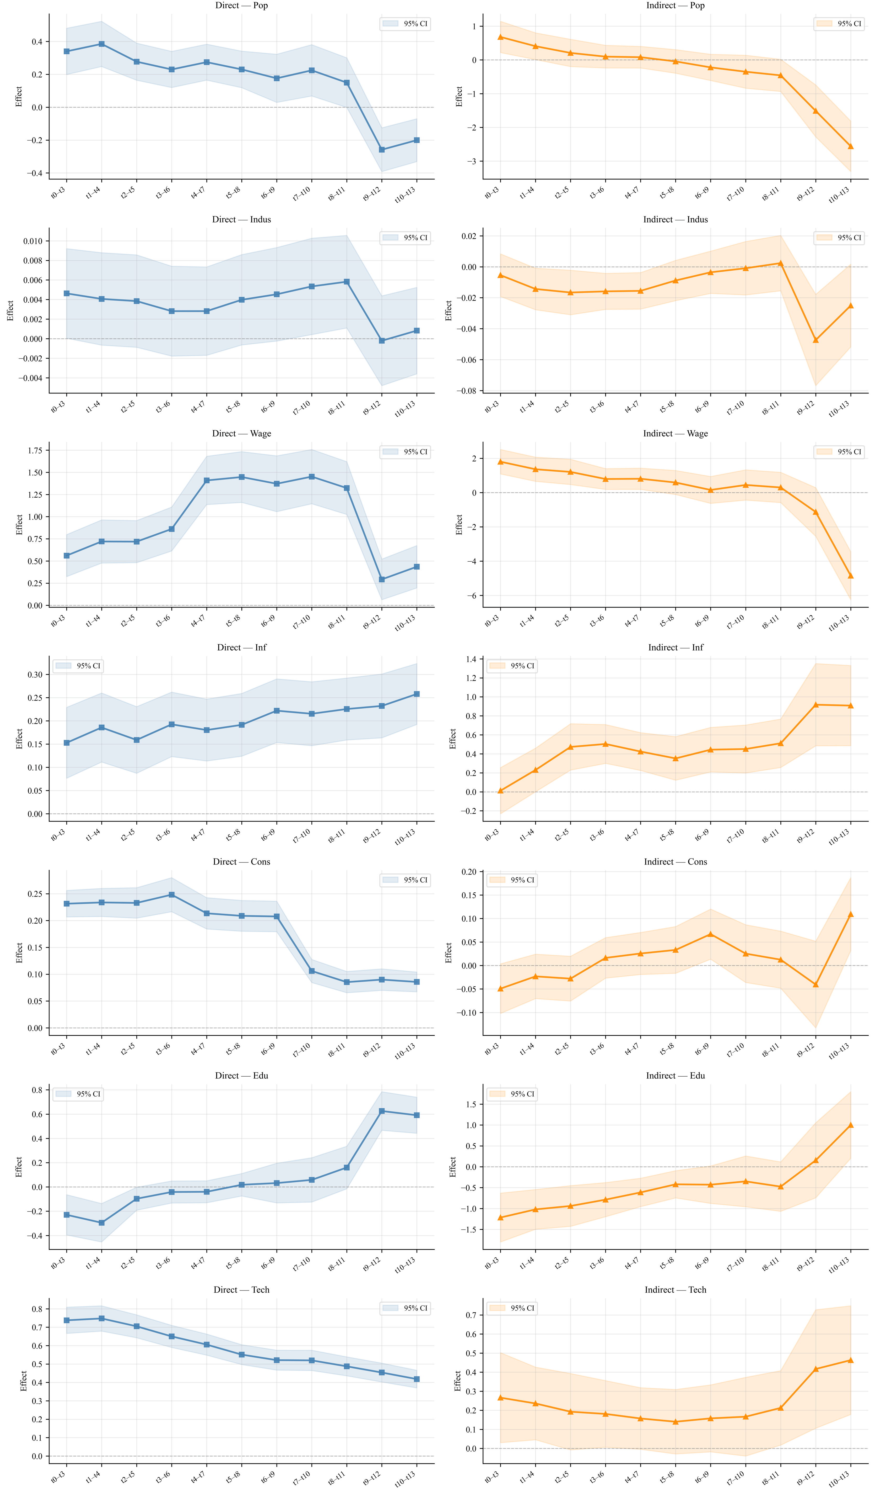
Figure 5 Rolling direct and indirect effects of explanatory variables on green innovation over successive four-year windows.
Structurally stable direct effects, diverging indirect effects. Tech and Inf exhibit the most stable direct effects across all windows—Tech declining gradually from 0.78 to 0.40 and Inf rising steadily from 0.15 to 0.26—confirming their roles as durable local determinants of green innovation. Their indirect effects diverge: Tech's indirect effect rises in the final windows (to approximately 0.50), while Inf's climbs monotonically from near zero to approximately 0.90, suggesting transport network density has reached a threshold at which cross-city connectivity generates accelerating spillover returns.
Sign reversals coinciding with the 2017 policy break. Three variables exhibit sign changes clustering around 2016–2017. Pop's direct effect declines from approximately 0.40 to -0.22 and its indirect effect collapses from 0.85 to approximately -2.5 with sharply widening confidence bands, reflecting the structural shift away from labor-intensive green industries. Edu's direct effect crosses zero from -0.21 to 0.65 as local green labor markets deepened, while its indirect effect reverses from -1.25 to 1.0, signalling the emergence of regional knowledge networks in later windows. Cons's direct effect drops abruptly from approximately 0.23 to 0.09 after 2017, consistent with firms responding to regulatory mandates rather than market demand incentives.
Delayed collapse in Wage spillovers. Wage's direct effect follows an inverted-U, peaking at approximately 1.50 around 2015–2018 before falling to 0.35. More notably, its indirect effect begins at 2.0, turns negative around 2017–2018, and falls to approximately -5 by the final window—the largest sign reversal in the figure—indicating that high wages in neighboring cities shifted from stimulating regional demand for green innovation to exerting a competitive siphoning effect on capital and talent.
Indus: Persistent but deepening competition externality. The direct effect of industrial structure remains statistically indistinguishable from zero throughout. The indirect effect is persistently negative, deepening to approximately -0.06 in the 2017–2020 window, confirming that secondary-sector concentration in neighboring cities exerts a durable competition externality on local green innovation.
Across all variables, direct effects are consistently more stable than indirect effects—narrower confidence bands, lower Coefficient of Variations (CVs,Table 10)—reflecting that local innovation outcomes depend on durable structural factors, while spatial spillovers remain sensitive to the evolving intensity of inter-city competition and market integration during China's green transition.
Table 10 Rolling-Window Effect Estimates
Variable | Direct Effects (D) |  |  |  | Indirect Effects (I)
Variable | Mean | Std. Dev. | CV |  | Mean | Std. Dev. | CV
Pop | 0.1660 | 0.1974 | 1.189 |  | -0.3339 | 0.8891 | 2.663
Indus | 0.0035 | 0.0018 | 0.501 |  | -0.0137 | 0.0131 | 0.956
Wage | 0.9627 | 0.4250 | 0.441 |  | 0.1324 | 1.7344 | 13.102
Inf | 0.2012 | 0.0307 | 0.153 |  | 0.4753 | 0.2485 | 0.523
Cons | 0.1766 | 0.0654 | 0.370 |  | 0.0134 | 0.0453 | 3.372
Edu | 0.0711 | 0.2809 | 3.952 |  | -0.4635 | 0.5855 | 1.263
Tech | 0.5815 | 0.1098 | 0.189 |  | 0.2355 | 0.1031 | 0.438

Temporal Heterogeneity Before and After 2017
The rolling-window analysis in Figure 5 reveals a consistent structural shift across multiple variables around 2016–2017: the direct effect of Cons drops abruptly, Pop's direct and indirect effects reverse sign, and Wage's indirect effect turns sharply negative. This co-movement motivates a formal sub-period analysis split at 2017, coinciding with a cluster of major environmental governance reforms — the 13th Five-Year Plan for Environmental Protection Standards, the Environmental Protection Tax Law, the Water Pollution Prevention and Control Law, and the launch of the national carbon emissions trading system.
Table 11 reports SDM estimates for the pre-2017 (2008–2016) and post-2017 (2017–2021) sub-periods. Post-2017, the spatial autoregressive coefficient declines from 1.371∗∗∗ to 0.530∗∗∗, indicating that inter-city green innovation spillovers remain positive and significant but have weakened in intensity. Two mechanisms account for this. First, intensified environmental regulation incentivized cities to build independent innovation capacity, reducing reliance on technology absorption from neighbors. Second, as green innovation capacity converged across cities — consistent with the narrowing spatial autocorrelation range documented in Figure 4 — the marginal return to cross-city spillover diminished.

Table 11. The Results of Heterogeneity Analysis

The spatial spillover of R&D investment (TW$×$Tech) shifted from $-{0.694}^{**}$to an insignificant $-0.010$, indicating that the pre-2017 crowding-out dynamic — in which R&D concentration in leading cities suppressed neighboring innovation — has dissipated. A parallel attenuation is observed for TW$×$Pop (from $-{1.371}^{***}$to $-{0.605}^{***}$), consistent with the rolling-effect evidence that labor-intensive green industries are ceding ground to more technology-intensive modes. Together, these patterns confirm that 2017 marks a genuine structural break in China's green innovation spillover regime rather than a smooth trend.
Robustness
Alternative STWM specifications. Table 12 reports estimates using Getis-Ord General G and Gini-based temporal weight matrices as alternatives to the baseline Moran's I and Geary's C. The spatial autoregressive coefficient of green innovation is stable at approximately 0.256 for the clustering-based metrics (Getis) and 0.300 for the Gini variant. The signs and significance of indirect effects for Wage, Technology, and Education are consistent across all four specifications, confirming that the detected spillovers reflect structural features of the data rather than an artefact of the specific weighting metric.
Table 12 STWM Variant Comparison (Different measure)
Variables | Panel A: β (Own effects) |  |  | Panel B: θ (Spatial-lag effects)
Variables | STWM_G  (Getis) | STWM_Gi  (Gini) |  | STWM_G  (Getis) | STWM_Gi  (Gini)
Pop | 0.1072*** | 0.1031*** |  | 0.3023*** | 0.2059*
 | (0.0351) | (0.0352) |  | (0.1123) | (0.1115)
Indus | -0.0004 | -0.0005 |  | -0.0249*** | -0.0252***
 | (0.0013) | (0.0013) |  | (0.0033) | (0.0033)
Wage | 0.3553*** | 0.3405*** |  | 2.0067*** | 1.7511***
 | (0.0624) | (0.0635) |  | (0.1726) | (0.1729)
Inf | 0.2141*** | 0.2151*** |  | 0.2272*** | 0.2353***
 | (0.0198) | (0.0198) |  | (0.0682) | (0.0681)
Cons | 0.1651*** | 0.1661*** |  | -0.0323** | -0.0444***
 | (0.0067) | (0.0067) |  | (0.0162) | (0.0160)
Edu | 0.1308*** | 0.1355*** |  | -1.0172*** | -0.9282***
 | (0.0354) | (0.0354) |  | (0.1349) | (0.1330)
Tech | 0.5715*** | 0.5711*** |  | 0.0840 | 0.0556
 | (0.0153) | (0.0153) |  | (0.0676) | (0.0664)
 | Panel C: Direct effects |  |  | Panel D: Indirect effects
Pop | 0.1085*** | 0.1044*** |  | 0.4420*** | 0.3374**
 | (0.0351) | (0.0352) |  | (0.1515) | (0.1594)
Indus | -0.0005 | -0.0007 |  | -0.0335*** | -0.0361***
 | (0.0013) | (0.0013) |  | (0.0048) | (0.0051)
Wage | 0.3637*** | 0.3504*** |  | 2.8119*** | 2.6397***
 | (0.0622) | (0.0633) |  | (0.2522) | (0.2588)
Inf | 0.2152*** | 0.2167*** |  | 0.3781*** | 0.4271***
 | (0.0198) | (0.0198) |  | (0.0863) | (0.0923)
Cons | 0.1652*** | 0.1661*** |  | 0.0134 | 0.0078
 | (0.0067) | (0.0068) |  | (0.0166) | (0.0177)
Edu | 0.1269*** | 0.1308*** |  | -1.3185*** | -1.2640***
 | (0.0354) | (0.0354) |  | (0.1870) | (0.1962)
Tech | 0.5724*** | 0.5723*** |  | 0.3088*** | 0.3236***
 | (0.0152) | (0.0153) |  | (0.0699) | (0.0737)
Spatial lag ρ | 0.2562*** | 0.3005*** |  | Overall Model Statistics
 | (0.0577) | (0.0566)
Observations (N) | 3,864 | 3,864
σ² | 0.5509 | 0.5525
Notes: *** p < 0.01, ** p < 0.05, * p < 0.10. Standard errors are in parentheses. The table compares the STWM_G (Getis) and STWM_Gi (Gini) variants. Panel A and B report the estimated coefficients, while Panel C and D report the calculated marginal effects.

Estimation method comparison. Table 13 reports direct, indirect, and total effects estimated by maximum likelihood/quasi-maximum likelihood (ML/QML), instrumental variables/generalized method of moments (IV/GMM), and Bayesian Markov chain Monte Carlo (MCMC). Estimates are qualitatively identical across all three methods, and the sign and significance of all indirect effects are preserved. This cross-method consistency confirms that the results are not sensitive to the choice of estimator.
Table 13 SDM Estimation Methods Comparison: ML/QML, IV/GMM, and Bayes
Variables | ML / QML |  |  | IV / GMM |  |  | Bayes
Variables | Direct | Indirect | Total | Direct | Indirect | Total | Direct | Indirect | Total
Pop | 0.109*** | 0.427*** | 0.536*** | 0.113*** | 0.390*** | 0.503*** | 0.112*** | 0.397*** | 0.509***
 | (0.035) | (0.152) | (0.158) | (0.035) | (0.118) | (0.122) | (0.036) | (0.118) | (0.122)
Indus | -0.000 | -0.032*** | -0.033*** | -0.000 | -0.028*** | -0.028*** | -0.000 | -0.029*** | -0.029***
 | (0.001) | (0.005) | (0.005) | (0.001) | (0.004) | (0.004) | (0.001) | (0.004) | (0.004)
Wage | 0.358*** | 2.773*** | 3.131*** | 0.350*** | 2.337*** | 2.687*** | 0.355*** | 2.409*** | 2.764***
 | (0.062) | (0.249) | (0.246) | (0.062) | (0.245) | (0.245) | (0.063) | (0.167) | (0.161)
Inf | 0.216*** | 0.374*** | 0.590*** | 0.219*** | 0.285*** | 0.503*** | 0.217*** | 0.299*** | 0.515***
 | (0.020) | (0.086) | (0.091) | (0.020) | (0.077) | (0.079) | (0.020) | (0.069) | (0.073)
Cons | 0.165*** | 0.013 | 0.178*** | 0.165*** | 0.042** | 0.206*** | 0.165*** | 0.036*** | 0.201***
 | (0.007) | (0.017) | (0.019) | (0.007) | (0.018) | (0.019) | (0.007) | (0.014) | (0.016)
Edu | 0.127*** | -1.293*** | -1.166*** | 0.115*** | -1.165*** | -1.050*** | 0.119*** | -1.192*** | -1.073***
 | (0.035) | (0.187) | (0.191) | (0.036) | (0.150) | (0.150) | (0.036) | (0.144) | (0.147)
Tech | 0.572*** | 0.305*** | 0.878*** | 0.577*** | 0.307*** | 0.884*** | 0.575*** | 0.311*** | 0.886***
 | (0.015) | (0.070) | (0.071) | (0.015) | (0.054) | (0.055) | (0.015) | (0.058) | (0.059)
Spatial Lag | 0.256*** |  |  | 0.041 |  |  | 0.087***
 | (0.058) |  |  | (0.116) |  |  | (0.022)
Note: *** p < 0.01, ** p < 0.05, * p < 0.10. Standard errors are reported in parentheses.

Monte Carlo validation. To assess the finite-sample properties of the SDM estimator under the proposed STWM, we conduct a Monte Carlo simulation with 200 replications using the empirical data structure ($n=276$ cities, $T=14$ years). Figure 6 presents the results. The distribution of $\hat{ρ }$is approximately normal and centered close to the true value, with RMSE = 0.0398 and 95 percent CI coverage of 0.950, marginally below the nominal 0.95. Bias and RMSE are uniformly small across all seven regressors, with direct-effect estimates consistently outperforming spatial-lag ($STWM*X$) counterparts.
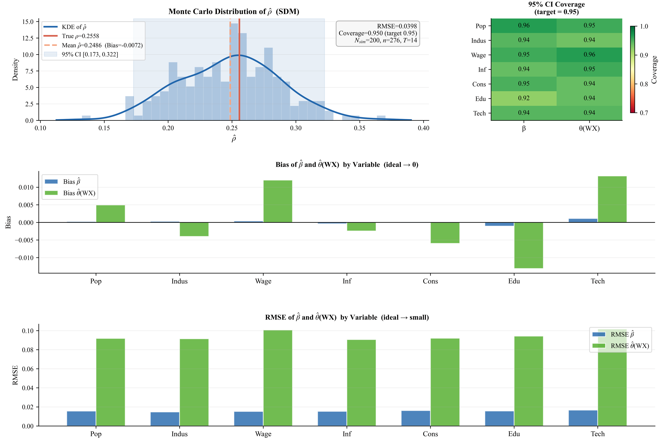
Figure 6 Monte Carlo simulation results for the SDM estimator under the proposed STWM.

Moran's I permutation tests. Figure 7 presents permutation-based significance tests for Moran's I in four representative years — 2008 (A), 2015 (B), 2018 (C), and 2021 (D). Each panel contains two components. The left sub-figure shows the reference distribution: the grey histogram plots the Moran's I statistics generated from 999 random permutations of the spatial units, representing the empirical null distribution under the assumption of no spatial dependence. The blue dashed line marks the mean of this null distribution (approximately zero). The red vertical line marks the observed Moran's I for that year. In all four panels, the red line falls far to the right of the null distribution — well beyond the 99th percentile — confirming that the observed degree of spatial clustering in green innovation is statistically significant at the 1 percent level and cannot be attributed to chance. The right sub-figure shows the corresponding Moran scatterplot, where each point represents a city, the horizontal axis is its standardized green innovation value, and the vertical axis is the spatially lagged mean of its neighbors. The red regression line has a positive slope in all four years, with the slope coefficient equal to the Moran's I statistic. A positive slope indicates that cities with high green innovation systematically neighbor other high-innovation cities — confirming positive spatial autocorrelation. The consistency of both results across all four years — the red line always in the right tail, the regression slope always positive — demonstrates that the spatial dependence structure underpinning the STWM is stable throughout the study period and is not an artefact of any particular year or policy sub-period.
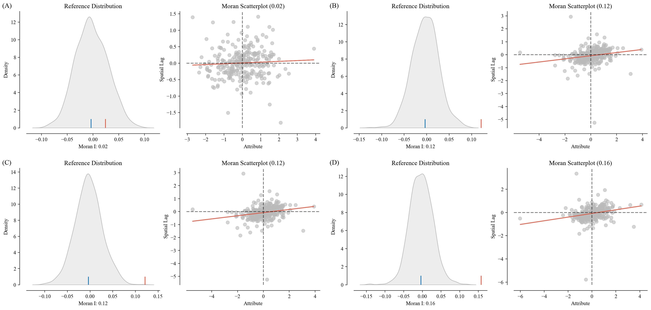
Figure 7. Robustness checks for Moran’s I using permutation tests and Moran scatterplots for selected years.

Heteroskedasticity-robust standard errors. Table 14 re-estimates the baseline SDM with STW$M_{I}$ using HC3 heteroskedasticity-robust and city-level clustered standard errors. Direct-effect coefficients (Panel A) are broadly stable: Wage, Inf, Cons, Edu, and Tech retain significance at conventional levels under both corrections, while Pop loses significance under city clustering, indicating within-cluster heterogeneity in population effects. Among the spatial lag coefficients (Panel B), Indus and Wage remain robustly significant; Pop, Inf, and Cons attenuate under city clustering, suggesting these spillover channels are sensitive to within-cluster correlation. The stability of the core coefficients across both correction methods confirms that heteroskedasticity does not materially distort the baseline estimates.
Table 14 Robust and Cluster Standard Errors of SDM for STWM_I
SDM (STWM_I) — Robust & Clustered Standard Errors
Variables | HC3 | City-Cluster
Panel A
Pop | 0.108** | 0.108
 | (0.046) | (0.098)
Indus | -0.000 | -0.000
 | (0.002) | (0.004)
Wage | 0.350*** | 0.350***
 | (0.069) | (0.120)
Inf | 0.215*** | 0.215***
 | (0.022) | (0.048)
Cons | 0.165*** | 0.165***
 | (0.019) | (0.050)
Edu | 0.131*** | 0.131*
 | (0.049) | (0.079)
Tech | 0.571*** | 0.571***
 | (0.018) | (0.043)
Panel B —WX
Pop | 0.291** | 0.291
 | (0.143) | (0.417)
Indus | -0.024*** | -0.024***
 | (0.003) | (0.006)
Wage | 1.980*** | 1.980***
 | (0.208) | (0.570)
Inf | 0.225*** | 0.225
 | (0.068) | (0.173)
Cons | -0.033** | -0.033
 | (0.014) | (0.034)
Edu | -0.999*** | -0.999**
 | (0.163) | (0.463)
Tech | 0.082 | 0.082
 | (0.055) | (0.147)
Notes: Standard errors are reported in parentheses. *** p<0.01, ** p<0.05, * p<0.10.

Conclusions
This paper makes a methodological and empirical contribution to the spatial econometrics literature through the construction and application of Spatial-Temporal Weight Matrices (STWMs). Methodologically, the STWM is formed as the Kronecker product of a temporal weight matrix — derived from year-on-year ratios of Moran's I and Geary's C — and a conventional spatial weight matrix. This construction is formally shown to satisfy all admissibility conditions for spatial econometric estimation (Theorem 1). Relative to static spatial weight matrices, the STWM reduces AIC and BIC by 217 points and passes a redundancy test (F=44.173, p < 0.001), while Hausman tests and Granger causality tests jointly confirm that the temporal weights are exogenous and do not create circular identification. The framework offers a replicable and theoretically grounded approach to embedding temporal dynamics into spatial regression, with potential application beyond the green innovation context studied here.
Empirically, applying the STWM within a Spatial Durbin Model to 276 Chinese cities from 2008 to 2021 yields three sets of findings. First, at the national level, green innovation exhibits significant positive spatial spillovers (0.256∗∗∗). Technological investment and infrastructure generate positive effects through both local and cross-city channels, while education investment creates a sharp tension: a positive direct effect (0.127∗∗∗) is offset by a large negative indirect effect (−1.293∗∗∗), reflecting inter-city competition for skilled labor that intensifies as green industries expand. Industrial structure exerts no significant local effect but imposes a persistent negative competition externality on neighboring cities (−0.032∗∗∗).
Second, the rolling-window analysis and the 2017 structural break together document a systematic regime shift in China's green innovation spillover structure. Before 2017, R&D concentration in leading cities crowded out neighboring innovation (STWM×Tech =−0.694∗∗) and population growth reinforced polarization; after 2017, both effects attenuated substantially, the aggregate spillover coefficient fell from 1.371∗∗∗to 0.530∗∗∗, and the direct effect of education crossed from negative to positive as local green labor markets deepened. The rolling analysis further reveals that wage spillovers collapsed from +2.0 to approximately −5 over the study period — the most dramatic dynamic in the data — marking a shift from regional complementarity to inter-city competition for talent and capital.
Third, cluster-level analysis using a threshold-based diagnostic classification of Growth Pole Theory stages reveals strong heterogeneity. The Yangtze River Delta has advanced to the Interactive Stage (STWM×Y turning from −0.863∗∗∗to 1.373∗ ). Beijing-Tianjin-Hebei stands at the threshold of the Diffusion Stage, with polarization significantly attenuated but positive spillovers not yet established. The Greater Bay Area exhibits a non-monotone trajectory, reverting to polarization after a brief intermediate phase, driven by renewed high-tech concentration in core cities. The Chengdu-Chongqing zone has halted active siphoning but has not entered the Diffusion Stage. The Yangtze River Middle Reaches cluster is stalled in transition, with structural isomorphism and administrative fragmentation preventing the emergence of positive spillovers despite physical infrastructure improvements.
The STWM framework introduced in this paper is released as the open-source Python package stwm, making the full methodology—from temporal weight construction to spatial model estimation and validation—freely available for applications involving dynamic spatial dependence.
This study has two limitations. The generalizability of the STWM framework to other spatial processes — regional income convergence, pollution diffusion, public health outcomes — remains to be assessed. Additionally, while this paper analyzes heterogeneity across the five major clusters, sub-cluster dynamics and cross-cluster linkages constitute a natural extension, particularly given the evidence of stage-divergent trajectories documented here.

Disclosure Statement
No potential conflict of interest was reported by the authors.

Data availability
Data will be made available on request.

Acknowledgments
This work was supported by the Hong Kong Research Grants Council (RGC) Research Fellow Scheme (RFS) [grant number HKUST RFS2425-6H03]; the Hong Kong Public Policy Research Funding Scheme (PPRFS) [grant numbers 2024.A7.032.24B; E2025.A7.039]; the Hong Kong Strategic Public Policy Research Funding Scheme (SPPRFS) [grant number S2024.A7.022]; the Innovation and Technology Support Programme, Hong Kong SAR Government [grant number ITS/003/24SC]; and the Hong Kong Research Grants Council (RGC) Strategic Topics Grant (STG) [grant number STG2/E- 605/23-N].

Author biography
PENGYU ZHU is a Professor in the Division of Public Policy at the Hong Kong University of Science and Technology, Hong Kong, China. He is also Director of the Center for AI in Economic, Social, and Environmental Research and Associate Director of the GREAT Smart Cities Institute. E-mail: pengyuzhu@ust.hk. His research interests include AI and data science in urban and regional systems, blockchain and real-world assets, low-altitude economic development, travel behavior dynamics, location choice, and the relationships among transportation infrastructure, housing markets, and regional economic development.

ZINING WANG is a PhD student in the Division of Public Policy at the Hong Kong University of Science and Technology, Hong Kong, China. E-mail: zwangpe@connect.ust.hk. Her research interests include green innovation, environmental economics, spatial and spatiotemporal analysis, AI and data science in and regional economic development.

List of figure captions
Figure 1. Dynamic stages of Green Growth Pole Theory and the spatial distribution of China’s five major urban clusters.
Figure 2. The process of spatial-temporal weight matrix (STWM) construction.
Figure 3. Hausman test framework for assessing the exogeneity of the STWM.
Figure 4. Spatial autocorrelation test of green innovation across 276 Chinese cities, 2008–2021.
Figure 5. Rolling direct and indirect effects of explanatory variables on green innovation over successive four-year windows.
Figure 6. Monte Carlo simulation results for the SDM estimator under the proposed STWM.
Figure 7. Robustness checks for Moran’s I using permutation tests and Moran scatterplots for selected years.

References
Anselin, L. (1988). Spatial econometrics: Methods and models (Vol. 4). Springer Netherlands. https://doi.org/10.1007/978-94-015-7799-1
Anselin, L. (2003). Spatial econometrics. In A Companion to Theoretical Econometrics (pp. 310–330). John Wiley & Sons, Ltd. https://doi.org/10.1002/9780470996249.ch15
Anselin, L., Syabri, I., & Kho, Y. (2006). GeoDa: An introduction to spatial data analysis. Geographical Analysis, 38(1), 5–22. https://doi.org/10.1111/j.0016-7363.2005.00671.x
Audretsch, D. B., & Feldman, M. P. (2004). Chapter 61—Knowledge spillovers and the geography of innovation. In J. V. Henderson & J.-F. Thisse (Eds.), Handbook of Regional and Urban Economics (Vol. 4, pp. 2713–2739). Elsevier. https://doi.org/10.1016/S1574-0080(04)80018-X
Baltagi, B. H. (2021). Spatial panel data models. In B. H. Baltagi (Ed.), Econometric Analysis of Panel Data (pp. 391–424). Springer International Publishing. https://doi.org/10.1007/978-3-030-53953-5_13
Becker, B., Roper, S., & Vanino, E. (2023). Assessing innovation spillovers from publicly funded R&D and innovation support: Evidence from the UK. Technovation, 128, 102860. https://doi.org/10.1016/j.technovation.2023.102860
Boudeville J-R., 1966, Problems of Regional Economic Planning. Edinburgh University Press
Chen, P., Xie, R., Lu, M., & Huang, Z. (2021). The impact of the spatio-temporal neighborhood effect on urban eco-efficiency in China. Journal of Cleaner Production, 285, 124860. https://doi.org/10.1016/j.jclepro.2020.124860
Chen, Z., Zhang, J., & Zi, Y. (2021). A cost-benefit analysis of R&D and patents: Firm-level evidence from China. European Economic Review, 133, 103633. https://doi.org/10.1016/j.euroecorev.2020.103633
Cheng, W., & Lee, L. (2017). Testing endogeneity of spatial and social networks. Regional Science and Urban Economics, 64, 81–97. https://doi.org/10.1016/j.regsciurbeco.2017.03.005
Cisneros Chavira, P., Shamsuzzoha, A., Kuusniemi, H., & Jovanovski, B. (2023). Defining green innovation, its impact, and cycle – a literature analysis. Cleaner Engineering and Technology, 17, 100693. https://doi.org/10.1016/j.clet.2023.100693
Corrado, L., & Fingleton, B. (2012). Where is the economics in spatial econometrics? Journal of Regional Science, 52(2), 210–239. https://doi.org/10.1111/j.1467-9787.2011.00726.x
Cooke, P., & Morgan, K. (1998). The Associational Economy: Firms, Regions, and Innovation. Oxford University Press. https://doi.org/10.1093/acprof:oso/9780198290186.001.0001
Deng, X. P. (1978). Emancipate the Mind, Seek Truth from Facts and Unite as One in Looking to the Future. In Selected Works of Deng Xiaoping (Vol. 2, pp. 150-163). Foreign Languages Press.
Démurger, S., Sachs, J. D., Woo, W. T., Bao, S., Chang, G., & Mellinger, A. (2002). Geography, economic policy, and regional development in China. Asian Economic Papers, 1(1), 146–197. https://doi.org/10.1162/153535102320264512
Dubé, J., Legros, D., Thériault, M., & Des Rosiers, F. (2014). A spatial difference-in-differences estimator to evaluate the effect of change in public mass transit systems on house prices. Transportation Research Part B: Methodological, 64, 24–40. https://doi.org/10.1016/j.trb.2014.02.007
Dubin, R. A. (1998). Spatial autocorrelation: A primer. Journal of Housing Economics, 7(4), 304–327. https://doi.org/10.1006/jhec.1998.0236
Elhorst, J. P. (2014). Spatial econometrics: From cross-sectional data to spatial panels. Springer Berlin Heidelberg. https://doi.org/10.1007/978-3-642-40340-8
Fagerberg, J., Srholec, M., & Verspagen, B. (2010). Chapter 20—Innovation and economic development. In B. H. Hall & N. Rosenberg (Eds.), Handbook of the Economics of Innovation (Vol. 2, pp. 833–872). North-Holland. https://doi.org/10.1016/S0169-7218(10)02004-6
Fan, Q., & Hudson, D. (2018). A new endogenous spatial-temporal weight matrix based on ratios of global Moran's I. Journal of Quantitative & Technical Economics, 35(1), 131–148 (in Chinese). https://doi.org/10.13653/j.cnki.jqte.20171228.007
Fankhauser, S., Bowen, A., Calel, R., Dechezleprêtre, A., Grover, D., Rydge, J., & Sato, M. (2013). Who will win the green race? In search of environmental competitiveness and innovation. Global Environmental Change, 23(5), 902–913. https://doi.org/10.1016/j.gloenvcha.2013.05.007
Fingleton, B., & Le Gallo, J. (2008). Estimating spatial models with endogenous variables, a spatial lag and spatially dependent distrurbances: Finite sample properties. Papers in Regional Science, 87(3), 319–339. https://doi.org/10.1111/j.1435-5957.2008.00187.x
Gao, Y., Cheng, J., Meng, H., & Liu, Y. (2019). Measuring spatio-temporal autocorrelation in time series data of collective human mobility. Geo-Spatial Information Science, 22(3), 166–173. https://doi.org/10.1080/10095020.2019.1643609
Geppert, K., Happich, M., & Stephan, A. (2008). Regional disparities in the European Union: Convergence and agglomeration. Papers in Regional Science, 87(2), 193–217. https://doi.org/10.1111/j.1435-5957.2007.00161.x
Hirschman, Albert Otto. (1958). The strategy of economic development. New Haven, Yale University.
Kelejian, H., Tavlas, G. S., & Petroulas, P. (2012). In the neighborhood: The trade effects of the euro in a spatial framework. Regional Science and Urban Economics, 42(1), 314–322. https://doi.org/10.1016/j.regsciurbeco.2011.09.007
Kemp, R., & Pontoglio, S. (2011). The innovation effects of environmental policy instruments—A typical case of the blind men and the elephant? Ecological Economics, 72, 28–36. https://doi.org/10.1016/j.ecolecon.2011.09.014
Kolstad, C. D. (2011). Environmental economics. Oxford University Press.
Krugman, P. (1991). Increasing returns and economic geography. Journal of Political Economy, 99(3), 483–499.
Leenders, R. Th. A. J. (2002). Modeling social influence through network autocorrelation: Constructing the weight matrix. Social Networks, 24(1), 21–47. https://doi.org/10.1016/S0378-8733(01)00049-1
Lesage, J. P., & Ha, C. L. (2012). The Impact of Migration on Social Capital: Do Migrants Take Their Bowling Balls with Them? Growth and Change, 43(1), 1–26. https://doi.org/10.1111/j.1468-2257.2011.00575.x
LeSage, J., & Pace, R. K. (2009). Introduction to Spatial Econometrics. Chapman and Hall/CRC. https://doi.org/10.1201/9781420064254
Liu, Y., Liu, S., Shao, X., & He, Y. (2022). Policy spillover effect and action mechanism for environmental rights trading on green innovation: Evidence from china’s carbon emissions trading policy. Renewable and Sustainable Energy Reviews, 153, 111779. https://doi.org/10.1016/j.rser.2021.111779
Liu, Y., Zhang, X., Pan, X., Ma, X., & Tang, M. (2020). The spatial integration and coordinated industrial development of urban agglomerations in the Yangtze River economic belt, china. Cities, 104, 102801. https://doi.org/10.1016/j.cities.2020.102801
Marshall, A. (1890). The principles of economics. McMaster University Archive for the History of Economic Thought.

Myrdal, G. (1957). Economic Theory and Underdeveloped Regions. London: Gerald Duckworth
Nordhaus, W. D. (2021). 18 the double externality of green innovation. In The Spirit of Green: The Economics of Collisions and Contagions in a Crowded World (pp. 204–224). Princeton University Press. https://doi.org/10.1515/9780691215396-018
Paelinck, J. (1978). Spatial econometrics. Economics Letters, 1(1), 59–63. https://doi.org/10.1016/0165-1765(78)90097-6
Parent, O., & LeSage, J. P. (2008). Using the variance structure of the conditional autoregressive spatial specification to model knowledge spillovers. Journal of Applied Econometrics, 23(2), 235–256. https://doi.org/10.1002/jae.981
Perroux, F. (1950). Economic space: Theory and applications. Quarterly Journal of Economics, 64(1), 89–104. https://doi.org/10.2307/1881960
Rastogi, A. (2023). Impact of spillovers on technological changes. Nature Computational Science, 3(11), 914–914. https://doi.org/10.1038/s43588-023-00564-6
Shahnazi, R., & Dehghan Shabani, Z. (2021). The effects of renewable energy, spatial spillover of CO2 emissions and economic freedom on CO2 emissions in the EU. Renewable Energy, 169, 293–307. https://doi.org/10.1016/j.renene.2021.01.016
Shan, H., & Shao, S. (2024). Impact of green innovation on carbon reduction in China. Scientific Reports, 14(1), 14032. https://doi.org/10.1038/s41598-024-64554-y
Smith, T. E., & Wu, P. (2009). A spatio-temporal model of housing prices based on individual sales transactions over time. Journal of Geographical Systems, 11(4), 333–355. https://doi.org/10.1007/s10109-009-0085-9
Yusuf, S., & Nabeshima, K. (2005). Creative industries in East Asia. Cities, 22(2), 109–122. https://doi.org/10.1016/j.cities.2005.01.001
Wang, Z., & Zhu, Y. (2020). Do energy technology innovations contribute to CO2 emissions abatement? A spatial perspective. Science of The Total Environment, 726, 138574. https://doi.org/10.1016/j.scitotenv.2020.138574
Xu, L., Fan, M., Yang, L., & Shao, S. (2021). Heterogeneous green innovations and carbon emission performance: Evidence at China’s city level. Energy Economics, 99, 105269. https://doi.org/10.1016/j.eneco.2021.105269
Zhang, J., Kang, L., Li, H., Ballesteros-Pérez, P., Skitmore, M., & Zuo, J. (2020). The impact of environmental regulations on urban green innovation efficiency: The case of xi’an. Sustainable Cities and Society, 57, 102123. https://doi.org/10.1016/j.scs.2020.102123
Zhang, S., Dai, Y., & Lai, Y. (2019). Empirical analysis on the influencing factors of China’s total foreign trade. Journal of Applied Mathematics and Physics, 7(7), 1421–1428. https://doi.org/10.4236/jamp.2019.77095Zhu, P., Li, J., & Hou, Y. (2022). Applying a population flow–based spatial weight matrix in spatial econometric models: Conceptual framework and application to COVID-19 transmission analysis. Annals of the American Association of Geographers, 112(8), 2266–2286. https://doi.org/10.1080/24694452.2022.2060791

Appendix A. Decomposition of Spatial Effects for Urban Clusters
Table A1. Decomposition of Spatial Effects: Yangtze River Delta (YRD)
Variable | Effect | 2008-2012 | 2012-2017 | 2017-2021
Indus | Direct | 1.537*** | 1.455*** | 0.315
Indus | Indirect | -0.337 | 0.500 | -2.120**
Indus | Total | 1.200* | 1.955** | -1.804**
Inf | Direct | 0.057 | 0.167*** | -0.003
Inf | Indirect | 0.412** | 0.251** | -0.040
Inf | Total | 0.469** | 0.418*** | -0.043
Cons | Direct | 1.034*** | 0.898*** | 0.058*
Cons | Indirect | -0.405 | 0.131 | -0.035
Cons | Total | 0.629* | 1.030*** | 0.023
Wage | Direct | 0.822*** | 0.973*** | 1.992***
Wage | Indirect | -0.129 | 1.722** | -5.258**
Wage | Total | 0.693 | 2.695*** | -3.266
Tech | Direct | 0.181** | 0.095 | 0.542***
Tech | Indirect | 0.174 | 0.809*** | -0.494
Tech | Total | 0.355 | 0.904*** | 0.048
Note: *** p<0.01, ** p<0.05, * p<0.1.

Table A2. Decomposition of Spatial Effects: Beijing–Tianjin–Hebei (BTH)
Variable | Effect | (1)  2008-2012 | (2)  2012-2017 | (3)  2017-2021
Indus | Direct | -0.782 | 0.394 | 0.182
Indus | Indirect | -1.995 | 1.892 | -0.337
Indus | Total | -2.777* | 2.285 | -0.155
Inf | Direct | -0.388* | -0.354*** | 0.121
Inf | Indirect | -1.590** | -1.069* | 0.757*
Inf | Total | -1.978** | -1.423** | 0.878**
Cons | Direct | 2.435*** | 2.267*** | 0.438**
Cons | Indirect | 6.326*** | 3.805*** | -2.556**
Cons | Total | 8.761*** | 6.073*** | -2.118*
Wage | Direct | -0.169 | 0.605 | -0.790*
Wage | Indirect | 3.054** | 1.790 | -0.367
Wage | Total | 2.885* | 2.395 | -1.157
Tech | Direct | -0.327*** | -0.147 | 0.750***
Tech | Indirect | -1.072*** | -1.354*** | 0.119
Tech | Total | -1.399*** | -1.501*** | 0.868*

Table A3. Decomposition of Spatial Effects: Greater Bay Area (GBA)
Variable | Effect | (1)  2008-2012 | (2)  2012-2017 | (3)  2017-2021
Indus | Direct | 0.508 | 2.063*** | 0.548
Indus | Indirect | -0.788 | 9.217*** | 4.021**
Indus | Total | -0.280 | 11.280*** | 4.570**
Inf | Direct | 0.587** | 0.486*** | -0.312
Inf | Indirect | 1.372*** | 0.221 | -1.805**
Inf | Total | 1.958*** | 0.706** | -2.117***
Wage | Direct | 1.650** | -0.978 | -0.750
Wage | Indirect | 0.627 | 3.807** | 5.961***
Wage | Total | 2.277 | 2.830 | 5.211***
Tech | Direct | 0.497*** | 1.000*** | 1.145***
Tech | Indirect | 0.526 | -0.299 | 2.103***
Tech | Total | 1.022** | 0.701 | 3.247***

Table A4. Decomposition of Spatial Effects: Chengdu–Chongqing (CCZ)
Variable | Effect | (1)  2008-2012 | (2)  2012-2017 | (3)  2017-2021
Indus | Direct | -2.960*** | -2.222** | -0.258
Indus | Indirect | 3.266** | 6.735*** | 0.190
Indus | Total | 0.306 | 4.513** | -0.068
Inf | Direct | 0.262** | 0.107 | 0.309***
Inf | Indirect | -1.629*** | -0.062 | -0.836***
Inf | Total | -1.367*** | 0.045 | -0.527*
Wage | Direct | -0.588 | 0.824 | 0.494
Wage | Indirect | 4.054*** | 3.793** | -0.322
Wage | Total | 3.467** | 4.617*** | 0.172
Tech | Direct | 0.807*** | 0.719*** | 0.595***
Tech | Indirect | 2.034*** | 1.100*** | 0.793*
Tech | Total | 2.841*** | 1.818*** | 1.389***

Table A5. Decomposition of Spatial Effects: Yangtze River Middle Reaches (YRM)
Variable | Effect | (1)  2008-2012 | (2)  2012-2017 | (3)  2017-2021
Indus | Direct | 0.590 | -0.403 | -0.556
Indus | Indirect | -1.094 | -0.863 | -2.938***
Indus | Total | -0.504 | -1.266 | -3.493***
Inf | Direct | 0.155* | 0.411*** | 0.356***
Inf | Indirect | 0.368 | 1.160*** | 0.947***
Inf | Total | 0.523** | 1.571*** | 1.303***
Wage | Direct | 1.464*** | 1.884*** | 0.510*
Wage | Indirect | -2.044* | -0.706 | 2.999***
Wage | Total | -0.581 | 1.178 | 3.509***
Tech | Direct | 0.638*** | 0.545*** | 0.619***
Tech | Indirect | 1.739*** | 0.136 | -0.029
Tech | Total | 2.376*** | 0.680 | 0.589*

Appendix B. Weight Matrices Test
Table B1: TWM Sensitivity Analysis — Stability Across Hyperparameters
Variables | Direct Effects |  |  | Indirect Effects
Variables | Mean | Std. Dev. | CV | Mean | Std. Dev. | CV
Pop | 0.1089 | 0.0002 | 0.0018 | 0.4275 | 0.0020 | 0.0047
Indus | -0.0002 | 0.0000 | 0.0000 | -0.0324 | 0.0001 | 0.0041
Wage | 0.3581 | 0.0006 | 0.0017 | 2.7742 | 0.0029 | 0.0010
Inf | 0.2157 | 0.0001 | 0.0005 | 0.3747 | 0.0005 | 0.0013
Cons | 0.1652 | 0.0000 | 0.0000 | 0.0131 | 0.0000 | 0.0000
Edu | 0.1269 | 0.0002 | 0.0016 | -1.2936 | 0.0042 | 0.0032
Tech | 0.5723 | 0.0000 | 0.0000 | 0.3055 | 0.0012 | 0.0038
Notes: This table summarizes the estimates of the Spatial Durbin Model (SDM) using the STWM_I spatial weight matrix across 9 hyperparameter combinations. The Coefficient of Variation (CV) is calculated as the standard deviation divided by the absolute mean (std/|mean|). A CV value below 0.05 indicates that the estimates are virtually insensitive to the choice of hyperparameters.

Table B2. Illustrative Example of Spatio-Temporal Weight Matrices (T=3, n=4)
Panel A: Temporal Weight Matrix (TWM) & Annual Moran's I
Time Period | Moran's I | t = 1 | t = 2 | t = 3
t = 1 | 0.35 | 1.0000 | 0.0000 | 0.0000
t = 2 | 0.42 | 0.5455 | 0.4545 | 0.0000
t = 3 | 0.51 | 0.3867 | 0.3363 | 0.2770
Panel B: Spatial Weight Matrix (SWM, Row-standardised Contiguity)
Region | n = 1 | n = 2 | n = 3 | n = 4
n = 1 | 0.0000 | 0.5000 | 0.5000 | 0.0000
n = 2 | 0.5000 | 0.0000 | 0.0000 | 0.5000
n = 3 | 0.5000 | 0.0000 | 0.0000 | 0.5000
n = 4 | 0.0000 | 0.5000 | 0.5000 | 0.0000

Panel C: Spatio-Temporal Weight Matrix (STWM = TWM ⊗ SWM)
 | 1 | 2 | 3 | 4 | 5 | 6 | 7 | 8 | 9 | 10 | 11 | 12
1 | 0.0000 | 0.5000 | 0.5000 | 0.0000 | 0.0000 | 0.0000 | 0.0000 | 0.0000 | 0.0000 | 0.0000 | 0.0000 | 0.0000
2 | 0.5000 | 0.0000 | 0.0000 | 0.5000 | 0.0000 | 0.0000 | 0.0000 | 0.0000 | 0.0000 | 0.0000 | 0.0000 | 0.0000
3 | 0.5000 | 0.0000 | 0.0000 | 0.5000 | 0.0000 | 0.0000 | 0.0000 | 0.0000 | 0.0000 | 0.0000 | 0.0000 | 0.0000
4 | 0.0000 | 0.5000 | 0.5000 | 0.0000 | 0.0000 | 0.0000 | 0.0000 | 0.0000 | 0.0000 | 0.0000 | 0.0000 | 0.0000
5 | 0.0000 | 0.2727 | 0.2727 | 0.0000 | 0.0000 | 0.2273 | 0.2273 | 0.0000 | 0.0000 | 0.0000 | 0.0000 | 0.0000
6 | 0.2727 | 0.0000 | 0.0000 | 0.2727 | 0.2273 | 0.0000 | 0.0000 | 0.2273 | 0.0000 | 0.0000 | 0.0000 | 0.0000
7 | 0.2727 | 0.0000 | 0.0000 | 0.2727 | 0.2273 | 0.0000 | 0.0000 | 0.2273 | 0.0000 | 0.0000 | 0.0000 | 0.0000
8 | 0.0000 | 0.2727 | 0.2727 | 0.0000 | 0.0000 | 0.2273 | 0.2273 | 0.0000 | 0.0000 | 0.0000 | 0.0000 | 0.0000
9 | 0.0000 | 0.1934 | 0.1934 | 0.0000 | 0.0000 | 0.1682 | 0.1682 | 0.0000 | 0.0000 | 0.1385 | 0.1385 | 0.0000
10 | 0.1934 | 0.0000 | 0.0000 | 0.1934 | 0.1682 | 0.0000 | 0.0000 | 0.1682 | 0.1385 | 0.0000 | 0.0000 | 0.1385
11 | 0.1934 | 0.0000 | 0.0000 | 0.1934 | 0.1682 | 0.0000 | 0.0000 | 0.1682 | 0.1385 | 0.0000 | 0.0000 | 0.1385
12 | 0.0000 | 0.1934 | 0.1934 | 0.0000 | 0.0000 | 0.1682 | 0.1682 | 0.0000 | 0.0000 | 0.1385 | 0.1385 | 0.0000
Notes: The table presents a toy example (T=3, n=4) to illustrate the construction of the Spatio-Temporal Weight Matrix (STWM). Panel A shows the Temporal Weight Matrix (TWM), which is lower-triangular (ensuring causality is backward-in-time only) and row-standardised. The increasing Moran's I indicates that green-innovation clusters are intensifying each year. Panel B displays the 4-city Spatial Weight Matrix (SWM) based on row-standardised contiguity. Panel C shows the resulting 12×12 STWM, calculated as the Kronecker product of TWM and SWM (STWM = TWM ⊗ SWM). Economic interpretation: STWM[i,j] represents the weight from city j at time s to city i at time t. As Moran's I grows, the recent past receives more weight (e.g., TWM[3,2] > TWM[3,1]), encoding stronger cross-period transmission. The TWM satisfies admissibility conditions (non-negative, row-standardised, spectral radius ρmax = 1.0000 < 1), ensuring stability.

Table B3 Rolling Effects (Window = 4 years, STWM_I / TWM_I)
Window | Pop |  | Indus |  | Wage |  | Inf |  | Cons |  | Edu |  | Tech
Window | Direct | Indirect | Direct | Indirect | Direct | Indirect | Direct | Indirect | Direct | Indirect | Direct | Indirect | Direct | Indirect
t0–t3 | 0.34*** | 0.68*** | 0.00** | -0.01 | 0.56*** | 1.80*** | 0.15*** | 0.01 | 0.23*** | -0.05* | -0.23*** | -1.22*** | 0.74*** | 0.27**
t0–t3 | (0.07) | (0.24) | (0.00) | (0.01) | (0.12) | (0.36) | (0.04) | (0.12) | (0.01) | (0.03) | (0.08) | (0.30) | (0.04) | (0.12)
t1–t4 | 0.39*** | 0.41** | 0.00* | -0.01** | 0.72*** | 1.36*** | 0.19*** | 0.23** | 0.23*** | -0.02 | -0.29*** | -1.02*** | 0.75*** | 0.24**
t1–t4 | (0.07) | (0.20) | (0.00) | (0.01) | (0.12) | (0.36) | (0.04) | (0.12) | (0.01) | (0.02) | (0.08) | (0.24) | (0.04) | (0.10)
t2–t5 | 0.28*** | 0.21 | 0.00 | -0.02** | 0.72*** | 1.20*** | 0.16*** | 0.47*** | 0.23*** | -0.03 | -0.10** | -0.94*** | 0.70*** | 0.19*
t2–t5 | (0.06) | (0.21) | (0.00) | (0.01) | (0.12) | (0.38) | (0.04) | (0.12) | (0.01) | (0.02) | (0.05) | (0.25) | (0.03) | (0.10)
t3–t6 | 0.23*** | 0.10 | 0.00 | -0.02*** | 0.86*** | 0.79** | 0.19*** | 0.50*** | 0.25*** | 0.02 | -0.04 | -0.79*** | 0.65*** | 0.18**
t3–t6 | (0.06) | (0.17) | (0.00) | (0.01) | (0.13) | (0.31) | (0.04) | (0.10) | (0.02) | (0.02) | (0.05) | (0.21) | (0.03) | (0.09)
t4–t7 | 0.27*** | 0.08 | 0.00 | -0.02*** | 1.41*** | 0.81** | 0.18*** | 0.42*** | 0.21*** | 0.03 | -0.04 | -0.61*** | 0.61*** | 0.16*
t4–t7 | (0.06) | (0.16) | (0.00) | (0.01) | (0.14) | (0.32) | (0.03) | (0.10) | (0.01) | (0.02) | (0.05) | (0.17) | (0.03) | (0.08)
t5–t8 | 0.23*** | -0.04 | 0.00* | -0.01 | 1.45*** | 0.59 | 0.19*** | 0.35*** | 0.21*** | 0.03 | 0.02 | -0.42** | 0.55*** | 0.14
t5–t8 | (0.06) | (0.18) | (0.00) | (0.01) | (0.15) | (0.36) | (0.03) | (0.12) | (0.01) | (0.03) | (0.05) | (0.17) | (0.03) | (0.09)
t6–t9 | 0.18** | -0.22 | 0.00* | -0.00 | 1.37*** | 0.15 | 0.22*** | 0.44*** | 0.21*** | 0.07** | 0.03 | -0.43* | 0.52*** | 0.16*
t6–t9 | (0.07) | (0.20) | (0.00) | (0.01) | (0.16) | (0.40) | (0.03) | (0.12) | (0.01) | (0.03) | (0.08) | (0.23) | (0.03) | (0.09)
t7–t10 | 0.22*** | -0.35 | 0.01** | -0.00 | 1.45*** | 0.44 | 0.22*** | 0.45*** | 0.11*** | 0.03 | 0.06 | -0.35 | 0.52*** | 0.17
t7–t10 | (0.08) | (0.25) | (0.00) | (0.01) | (0.16) | (0.45) | (0.04) | (0.13) | (0.01) | (0.03) | (0.09) | (0.31) | (0.03) | (0.11)
t8–t11 | 0.15* | -0.46* | 0.01** | 0.00 | 1.32*** | 0.30 | 0.23*** | 0.51*** | 0.09*** | 0.01 | 0.16* | -0.48 | 0.49*** | 0.21**
t8–t11 | (0.08) | (0.24) | (0.00) | (0.01) | (0.15) | (0.45) | (0.03) | (0.13) | (0.01) | (0.03) | (0.09) | (0.30) | (0.03) | (0.10)
t9–t12 | -0.26*** | -1.51*** | -0.00 | -0.05*** | 0.29** | -1.13 | 0.23*** | 0.92*** | 0.09*** | -0.04 | 0.63*** | 0.15 | 0.45*** | 0.42***
t9–t12 | (0.07) | (0.39) | (0.00) | (0.02) | (0.12) | (0.72) | (0.04) | (0.22) | (0.01) | (0.05) | (0.08) | (0.46) | (0.03) | (0.16)
t10–t13 | -0.20*** | -2.56*** | 0.00 | -0.03* | 0.44*** | -4.85*** | 0.26*** | 0.91*** | 0.09*** | 0.11*** | 0.59*** | 1.00** | 0.42*** | 0.46***
t10–t13 | (0.07) | (0.38) | (0.00) | (0.01) | (0.12) | (0.72) | (0.03) | (0.22) | (0.01) | (0.04) | (0.08) | (0.41) | (0.02) | (0.15)
Notes: *** p<0.01, ** p<0.05, * p<0.10. Standard errors are reported in parentheses below the coefficients.

Theorem 1 implies that any ratio-based TWM constructed from a valid spatial autocorrelation statistic—whether Moran's I, Geary's C, Getis-Ord G, or Spatial Gini—yields an admissible STWM, provided the component matrices satisfy the stated conditions. This establishes the generality of the proposed construction beyond the specific statistics used in this paper
In practice ρ(W) = 1 exactly, since both TWM and SWM are row-stochastic and thus have 1 as their largest eigenvalue. The stability condition for spatial autoregressive estimation is therefore imposed on the autoregressive parameter ρ (requiring |ρ| < 1), not on the weight matrix itself—a point occasionally misreported in applied software output.
The 13th Five-Year Plan for National Integrated Rural Environment Management. https://english.mee.gov.cn/Resources/Plans/Special_Fiveyear_Plan/201902/t20190222_693384.shtml Retrieved November 27, 2025.
https://github.com/ZiningPe/STWM/tree/main/stwm

