Non-Linear Distance Decay of Urban Amenities in Housing Prices: Evidence from Explainable Artificial Intelligence in a Hyper-Dense City
Teklebirhan Alemnew Gebeyehu^{1,2}, Pengyu Zhu^{1, 2,} *,
¹Division of Public Policy, Hong Kong University of Science and Technology (HKUST), Hong Kong SAR, China
²Center for AI in Economic, Social and Environmental Research (CAESER), HKUST, Hong Kong SAR, China

*Corresponding Author: Pengyu Zhu
pengyuzhu@ust.hk
Room 4616C, Academic Building, The Hong Kong University of Science and Technology, Clear Water Bay, Kowloon, Hong Kong SAR, China

Non-Linear Distance Decay of Urban Amenities in Housing Prices: Evidence from Explainable Artificial Intelligence in a Hyper-Dense City
Teklebirhan Alemnew Gebeyehu1,2, Pengyu Zhu1, 2, *,
¹Division of Public Policy, Hong Kong University of Science and Technology (HKUST), Hong Kong SAR, China
²Center for AI in Economic, Social and Environmental Research (CAESER), HKUST, Hong Kong SAR, China
*Corresponding Author Email address: pengyuzhu@ust.hk (P. Zhu)
Abstract
Urban amenities shape housing prices through spatially localized and distance-sensitive effects. Against this backdrop, this study examines the distance decay patterns of multiple urban amenities in Hong Kong, a hyper-dense and highly mixed-use city, using a large-scale dataset of 722,244 housing transactions from 2012 to 2020. An eXtreme Gradient Boosting (XGBoost) model is employed alongside explainable artificial intelligence (XAI) tools, specifically Accumulated Local Effects (ALE) and Shapley Additive Explanations (SHAP), to uncover continuous and interpretable distance-response relationships. Accessibility is measured using pedestrian walking network distance, offering a more behaviorally realistic representation of accessibility in a highly connected urban environment. The results reveal that amenity capitalization is strongly non-linear, threshold-dependent, and highly heterogeneous across amenity types. Positive effects are concentrated within amenity-specific service catchments, beyond which they weaken and, in many cases, become negative. Transport amenities exhibit distinct service catchments, with bus stops generating highly localized effects and metro stations influencing housing prices over broader network distances. Healthcare, commercial, recreational, and educational amenities similarly display differentiated and non-monotonic capitalization patterns that reflect their functional roles, accessibility benefits, and localized externalities. By identifying amenity-specific distance thresholds and continuous distance-response functions, this study advances the measurement of spatial capitalization and demonstrates the value of integrating explainable machine learning with network-based accessibility measures for urban analysis. The findings provide practical guidance for accessibility-based planning, optimal amenity placement, and evidence-based land-use planning in high-density urban environments.
Keywords: Urban amenities; Housing prices; Distance decay effect; Network distance; Explainable artificial intelligence; Hong Kong

- Introduction
The capitalization of location-specific urban amenities into housing prices is a central topic in urban economics, reflecting how households trade off accessibility, convenience, and environmental quality against housing costs (Gibbons & Machin, 2008; Yuan et al., 2020; Chen et al., 2025). In hyper-dense, mixed-use cities such as Hong Kong, where residential, commercial, transport, educational, healthcare, and recreational functions are tightly interwoven, these trade-offs occur within very short spatial ranges and are often highly non-linear (Wadu Mesthrige & Maqsood, 2022; D. Liu et al., 2024). Understanding how these proximity effects vary across distance is therefore essential for explaining housing price formation in compact urban environments.
Conventional hedonic pricing models typically rely on linear, semi-log, or distance-band specifications, implicitly assuming smooth and monotonic relationships between distance and housing prices (Rosen, 1974; Malpezzi, 2002; Seo et al., 2019). However, such assumptions are increasingly inconsistent with empirical evidence. Recent advances in spatial econometrics, such as Geographically Weighted Regression (GWR) and Multiscale GWR (MGWR), relax these assumptions by allowing model parameters to vary locally, thereby capturing spatial heterogeneity and non-stationarity (Páez et al., 2008; Huang et al., 2010; Fotheringham et al., 2017; Wu et al., 2019). However, they remain fundamentally parametric frameworks that require pre-specification of functional forms and are primarily designed to capture smoothly varying spatial processes. Consequently, they are less well suited to capturing complex non-linear interactions, abrupt turning points, and heterogeneous threshold effects arising from multiple interacting urban amenities in hyper-dense environments.
Recent advances in machine learning provide a promising alternative for modeling housing prices without imposing restrictive functional-form assumptions. Among these, eXtreme Gradient Boosting (XGBoost) has proven particularly effective because it flexibly models complex interactions while maintaining high predictive performance (Chen & Guestrin, 2016). Meanwhile, explainable artificial intelligence (XAI) techniques, particularly Shapley Additive Explanations (SHAP) and Accumulated Local Effects (ALE), have substantially improved the interpretability of machine learning models by quantifying feature contributions and recovering continuous response functions (Lundberg & Lee, 2017; Lundberg et al., 2018; Apley & Zhu, 2020; Molnar, 2021). Together, these methods provide a transparent framework for identifying heterogeneous, non-linear, and threshold-dependent accessibility effects that are difficult to recover using conventional hedonic and spatial econometric approaches. Unlike GWR/MGWR, however, XGBoost and XAI methods do not explicitly model spatial dependence or spatially varying coefficients, and they cannot by themselves eliminate spatial confounding arising from omitted spatially structured factors. Their comparative advantage instead lies in flexibly recovering complex, non-linear, and threshold-dependent relationships without imposing a pre-specified functional form.
Building on these methodological advances, recent studies have increasingly applied explainable machine learning to housing valuation (e.g., Chen et al., 2023; Dou et al., 2023; Chen et al., 2025; Lee et al., 2025). Lee et al. (2025), for example, demonstrate that SHAP can reveal complex non-linear distance decay relationships using straight-line distance that are not captured by traditional hedonic models. However, whether these relationships remain valid in hyper-dense urban environments characterized by extreme land scarcity, vertical development, and highly interconnected pedestrian networks, and whether they persist when accessibility is measured using pedestrian walking network distance rather than Euclidean distance, remains largely unexplored. Hong Kong provides an ideal setting to address this question because its unique urban morphology is likely to compress accessibility benefits and localized externalities into much shorter and more heterogeneous spatial ranges than those observed in lower-density cities.
Despite recent progress, several important research gaps remain. First, most existing studies examine individual amenity categories in isolation rather than systematically comparing how multiple urban amenities jointly influence housing prices within a unified analytical framework, particularly in hyper-dense urban systems. Second, accessibility is commonly measured using buffer-based indicators (e.g., counts or densities within predefined areas) (e.g., Chen et al., 2023; Dou et al., 2023) or straight-line (Euclidean) distance (e.g., Chen et al., 2025; Lee et al., 2025), both of which may inadequately represent actual pedestrian accessibility in complex urban environments such as Hong Kong. Third, much of the literature emphasizes predictive performance or feature importance while devoting limited attention to recovering continuous and interpretable distance-response functions that reveal amenity-specific thresholds and turning points (e.g., Chen et al., 2023; Dou et al., 2023). Finally, empirical evidence from hyper-dense cities such as Hong Kong remains scarce, despite the likelihood that extreme density, vertical urban form, and mixed land use fundamentally alter accessibility capitalization mechanisms.
To address these gaps, this study analyzes a large-scale dataset of 722,244 housing transactions in Hong Kong between 2012 and 2020 by integrating XGBoost with two complementary explainable artificial intelligence techniques (SHAP and ALE) to examine how urban amenities are capitalized into housing prices using pedestrian walking network distance.
This study makes four main contributions. First, it provides new empirical evidence on amenity capitalization in one of the world’s most compact and vertically structured cities, thereby extending recent findings derived primarily from lower-density metropolitan contexts. Second, it measures accessibility using pedestrian walking network distance rather than Euclidean distance, thereby providing a more behaviorally realistic characterization of amenity-specific service catchments and walkability thresholds. Third, it develops a unified analytical framework that jointly evaluates multiple categories of urban amenities, including transport, education (by stage), healthcare, commercial and retail services, and natural and recreational amenities, enabling systematic comparison of their relative importance, spatial thresholds, and distance decay patterns. Fourth, by integrating XGBoost with SHAP and ALE, the study demonstrates how explainable machine learning can move beyond prediction to recover continuous, interpretable, and policy-relevant distance-response functions for urban amenities in complex urban environments.
The rest of the paper is structured as follows: Section 2 reviews the relevant literature, Section 3 presents the study area, data, and methodology, Section 4 reports the empirical findings, and Section 5 concludes with policy implications.
- Literature review
Strong evidence from foundational hedonic studies shows that school quality and accessibility significantly influence housing prices (Gibbons & Machin, 2008; Feng & Lu, 2013; Wen et al., 2014, 2019). Transport accessibility also generates substantial price premiums by reducing commuting costs and improving connectivity (Gibbons & Machin, 2008; Lieske et al., 2019; Seo et al., 2019; Wadu Mesthrige & Maqsood, 2022). Urban greenspaces and recreational amenities further enhance property values by improving environmental quality and overall livability (Jim & Chen, 2006; Feng & Humphreys, 2012; Łaszkiewicz et al., 2022). In contrast, healthcare facilities (Peng & Chiang, 2015; Peng, 2021; Gu et al., 2024) and commercial hubs (Kholdy et al., 2014; Jang & Kang, 2015; Zhang et al., 2020) often exhibit more complex effects, reflecting the coexistence of accessibility benefits and localized externalities.
Despite this broad consensus, the functional form and spatial extent of amenity effects remain unresolved. Much of the literature relies on linear or semi-log specifications, or on discrete distance bands, implicitly assuming smooth and monotonic relationships. However, growing evidence suggests that amenity effects are highly non-linear and context-dependent. Proximity may generate positive effects through accessibility and agglomeration benefits, but also negative effects through congestion, noise, and crowding, leading to threshold or non-monotonic patterns (Jin et al., 2022; Dou et al., 2023). In dense urban environments, these opposing forces often operate within very short spatial ranges, making accurate identification of distance decay relationships particularly challenging.
To address these challenges, researchers have adopted more flexible analytical approaches. Spatial econometric models such as GWR and MGWR effectively handle spatial autocorrelation and non-stationarity by allowing model parameters to vary locally (Huang et al., 2010; Fotheringham et al., 2017; Wu et al., 2019). Quantile regression captures price-tier heterogeneity across different segments of the housing market (Peng, 2021; Wen et al., 2019). More recently, machine learning techniques have gained attention for their ability to model complex non-linear relationships and higher-dimensional interactions without imposing restrictive functional-form assumptions (Chen & Guestrin, 2016; Chen et al., 2023). Despite these advances, a key challenge remains: achieving high predictive accuracy while retaining interpretability and recovering continuous, amenity-specific distance-response functions.
Explainable artificial intelligence (XAI) methods have emerged as a promising solution to this trade-off. SHAP provides a theoretically grounded and consistent decomposition of feature contributions at both global and local levels. In this context, consistency implies that if a feature’s contribution to model output increases due to a model change, its SHAP value will not decrease, ensuring stable and comparable explanations (Lundberg & Lee, 2017; Molnar, 2021). This property is particularly relevant in the present study’s dataset because the thirteen distance-based amenity variables may be spatially correlated, as different amenities may be concentrated in the same urban locations. Consistent attribution is therefore important for making meaningful comparisons of the relative contributions of different amenity types to housing prices. ALE complements SHAP by providing a more locally accurate estimate of marginal effects than conventional partial dependence, particularly when predictors are correlated (Apley & Zhu, 2020; Molnar, 2021). Empirical applications demonstrate the effectiveness of these methods in revealing non-linear relationships, threshold effects, and spatial heterogeneity in housing markets (Dou et al., 2023; Lee et al., 2025; X. Liu et al., 2026).
However, most existing XAI-based studies measure accessibility using aggregated indicators (e.g., counts or densities within predefined buffers) (e.g., Chen et al., 2023; Dou et al., 2023) or straight-line (Euclidean) distance (e.g., Chen et al., 2025; Lee et al., 2025), which may inadequately represent actual pedestrian accessibility. This limitation is particularly important in hyper-dense, vertically structured cities such as Hong Kong, where walking routes are shaped by complex street layouts, topography, and multi-level pedestrian networks rather than straight-line distance. Moreover, many studies examine individual amenity categories in isolation, limiting systematic comparisons of distance decay patterns across different urban functions.
To address these limitations, this study measures accessibility using pedestrian walking network distance to the nearest facility and integrates XGBoost with SHAP and ALE within a unified analytical framework. Pedestrian network distance provides a more behaviorally realistic measure of accessibility, while the complementary use of SHAP and ALE provides different but mutually informative perspectives on the continuous, non-linear relationships captured by the fitted model. ALE can reduce the extrapolation problems associated with conventional partial dependence approaches when predictors are correlated (Apley & Zhu, 2020), but neither ALE nor SHAP resolves multicollinearity or spatial confounding in the underlying model. Correlated amenity variables may still share predictive information and affect feature attribution; accordingly, the resulting distance-response patterns are interpreted as model-based associations rather than causal effects. Although the nearest-facility approach does not capture the broader cumulative influence of all surrounding facilities, it is well suited to the study's objective of identifying continuous distance decay functions, walkability thresholds, and turning points at which accessibility benefits transition into disamenities. In a compact, hyper-dense city such as Hong Kong, the nearest-facility metric provides a consistent, behaviorally meaningful, and highly interpretable measure of immediate accessibility.
- Method
  - Study Area and Data
This study focuses on Hong Kong, a highly compact city characterized by extreme population density, mixed land use, and pronounced spatial heterogeneity in access to urban amenities. Beyond its exceptional density, Hong Kong exhibits a distinctive three-dimensional urban structure shaped by extensive high-rise development, steep topography, and interconnected multi-level pedestrian networks. In many districts, particularly on Hong Kong Island, accessibility is influenced not only by horizontal distance but also by elevation changes, vertical urban development, and pedestrian infrastructure. Consequently, actual walking routes often differ substantially from straight-line distances, making pedestrian walking network distance a more behaviorally realistic measure of accessibility. This vertically integrated urban environment, where residential, commercial, and other land uses are closely interwoven across multiple spatial layers, provides a unique setting for examining how proximity to amenities is capitalized into property prices. These characteristics may compress both positive amenity effects and negative externalities into shorter spatial ranges than those observed in lower-density cities. Such conditions provide an ideal setting for analyzing non-linear distance decay effects and identifying amenity-specific spatial thresholds in housing price formation.
The empirical analysis is based on a comprehensive dataset of property transactions covering the period from 2012 to 2020, capturing different phases of the property market cycle. Because the analysis pools transactions across these eight years, the estimated amenity thresholds represent average relationships over a period characterized by substantial temporal variation in Hong Kong’s property market. Consequently, time-varying macroeconomic and market conditions may be partly conflated with the estimated amenity effects. The data were subjected to systematic cleaning procedures to ensure reliability and consistency. Specifically, observations with missing values and logically invalid records, such as zero or negative housing prices and floor areas, were removed. To reduce the influence of extreme values, a percentile-based trimming procedure was applied, and transactions in the bottom 1st percentile and top 99th percentile of the unit housing price distribution were excluded. This approach is widely used in empirical housing and hedonic pricing studies as a transparent, data-driven method for mitigating the influence of outliers while preserving the underlying distribution of valid market transactions. After these cleaning procedures, the final dataset consists of 722,244 valid housing transactions, providing a large and robust sample for machine-learning–based modeling. Fig 1 shows the spatial distribution of housing prices in Hong Kong from 2012 to 2020.
The set of explanatory variables is designed to capture key determinants of property values, with a particular emphasis on accessibility to amenities. Structural characteristics include key property attributes such as the number of bedrooms and living rooms, which are widely recognized determinants of housing prices (Jim & Chen, 2006; Lee et al., 2025). In addition, property usage type is included as a control variable to account for systematic differences in pricing structures, market segmentation, and property functions across residential, commercial, office, and industrial properties. While certain property categories may be more likely to be located near specific amenities, diagnostic tests indicate that multicollinearity is not a concern (see Appendix 1). Accordingly, these controls help isolate locational accessibility from systematic differences across property types. Nonetheless, pooling residential, commercial, office, and industrial transactions into a single model, distinguished only by this categorical usage control, implicitly assumes that the general functional form of amenity capitalization is sufficiently comparable across property-market segments that may have different valuation mechanisms.
A central component of this study is measuring amenity accessibility, operationalized as the distance from each property to the nearest facility. This approach is consistent with a substantial body of literature showing that spatial proximity to amenities plays a key role in determining property values (Chen et al., 2025; Lee et al., 2025). To capture the multidimensional nature of urban environments, amenities are grouped into several categories. These categories are selected based on their established relevance in the housing valuation literature.
Educational facilities, including primary schools, secondary schools, and universities, are incorporated due to their strong influence on location desirability and housing demand (Feng & Lu, 2013; Wen et al., 2019). Transport accessibility is measured through distances to bus stops and metro stations, reflecting the critical role of public transit in shaping accessibility and property values in dense cities (Lieske et al., 2019; Wadu Mesthrige & Maqsood, 2022). Natural and recreational amenities, such as green spaces, scenic spots, and leisure and sports facilities, are included given their contribution to urban livability (Feng & Humphreys, 2012; Keeler et al., 2021; Dou et al., 2023).
Healthcare facilities, including hospitals and clinics, are considered essential services that influence neighborhood attractiveness and housing prices (Gu et al., 2024; Lee et al., 2025). Finally, commercial and retail amenities, including shopping malls, restaurants, and hotels, are incorporated to capture access to daily consumption and economic activities. While proximity to such amenities can enhance convenience and increase property values (Kholdy et al., 2014; Jang & Kang, 2015; Zhang et al., 2020), they may also generate congestion, noise, and other localized externalities. Summary statistics for these variables are shown in Table 1.
All accessibility variables are constructed as continuous nearest-facility measures using Geographic Information System (GIS) techniques and are calculated as the shortest pedestrian walking distance from each property to its nearest amenity along the street network. Compared with straight-line (Euclidean) distance, network distance more accurately reflects the routes that residents actually use to access urban amenities and therefore provides a more behaviorally realistic measure of accessibility. This distinction is particularly important in Hong Kong, where steep topography, dense high-rise development, and extensive pedestrian infrastructure, including footpaths, footbridges, tunnels, and other pedestrian connections represented in OpenStreetMap, often cause actual walking routes to deviate substantially from straight-line distance. Although the analysis does not explicitly model three-dimensional elevation changes or vertical movement within buildings (see Tang et al., 2021; Liu et al., 2025), the pedestrian network captures the available walkable connections and provides a substantially more realistic representation of accessibility than conventional Euclidean distance. This specification strengthens the empirical framework by enabling the identification of non-linear and threshold-based distance decay relationships that are difficult to detect using conventional linear or categorical approaches (Chen & Guestrin, 2016; Chen et al., 2025). By capturing actual rather than purely geometric accessibility, the network-based measure provides a more appropriate basis for analyzing how proximity to urban amenities is capitalized into housing prices in Hong Kong’s complex urban environment.
Table 1: Summary statistics ($n=722,244$)
Type | Variable | Mean | Std | Min | Max
Structural characteristics | Number of bedrooms | 1.612 | 1.209 | 0 | 7
Structural characteristics | Number of living rooms | 1.280 | 0.915 | 0 | 7
Transport amenities | Distance to bus stop (km) | 0.174 | 0.195 | 0 | 3.453
Transport amenities | Distance to metro station (km) | 2.109 | 3.169 | 0 | 21.835
Education facilities | Distance to primary school (km) | 1.158 | 1.311 | 0 | 27.016
Education facilities | Distance to secondary school (km) | 1.547 | 1.882 | 0 | 18.242
Education facilities | Distance to university (km) | 1.407 | 1.747 | 0 | 27.491
Healthcare services | Distance to hospital (km) | 0.893 | 0.736 | 0 | 10.113
Healthcare services | Distance to clinic (km) | 0.563 | 0.611 | 0 | 7.116
Commercial & Retail Amenities | Distance to shopping mall (km) | 0.507 | 0.543 | 0 | 9.295
Commercial & Retail Amenities | Distance to restaurant (km) | 0.379 | 0.405 | 0 | 6.585
Commercial & Retail Amenities | Distance to hotel (km) | 1.132 | 1.072 | 0 | 8.786
Natural and recreational amenities | Distance to greenspace/park (km) | 0.551 | 0.475 | 0 | 2.998
Natural and recreational amenities | Distance to leisure/sport (km) | 0.395 | 0.365 | 0 | 2.997
Natural and recreational amenities | Distance to scenic spot (km) | 0.443 | 0.403 | 0 | 2.996
Housing price | Unit sales price (in 10,000 HKD) (in log) | 2.485 | 0.582 | 0.592 | 4.023
Figure 1. Spatial distribution of housing prices in Hong Kong (2012-2020)
  - eXtreme Gradient Boosting (XGBoost) model
To examine the distance decay effect of urban amenities on housing prices, this study employs eXtreme Gradient Boosting (XGBoost), a robust ensemble machine learning method designed to capture complex and non-linear relationships. Conventional hedonic approaches typically rely on linear or log-linear specifications, which impose restrictive functional forms and often fail to capture the true complexity of the relationships between housing prices and their determinants. In contrast, XGBoost provides a flexible, data-driven framework that can uncover intricate patterns in the relationship between accessibility and property values without requiring prior assumptions about functional form (Chen & Guestrin, 2016; Chen et al., 2023, 2025).
XGBoost builds predictions through an additive ensemble of $K$ regression trees. For a given observation 𝑖, the predicted housing price is expressed as:
$$\begin{aligned}\hat{y_{i}}=\sum_{k=1}^{K}{f_{k}\left(x_{i}\right), f_{k}∈F}\#\left(1\right)\end{aligned}$$
Where $x_{i}∈R^{m}$ represents the feature vector of the $i^{th}$ observation, $f_{k}$​ denotes the $k^{th}$ regression tree, and $F$ denotes the functional space of regression trees. The model is constructed iteratively, with each new tree fitted to the errors of the previous ensemble, allowing the algorithm to progressively refine its predictions and capture complex feature interactions.
A defining feature of XGBoost is its regularized objective function, designed to balance predictive accuracy with model complexity. The objective function consists of a loss term and a penalty component:
$$\begin{aligned}L=\sum_{i=1}^{n}{l\left(y_{i},{\hat{y}}_{i}\right)+\sum_{k=1}^{K}{Ω(f_{k}​)}}\#\left(2\right)\end{aligned}$$
Where $l(.)$ represents the loss function measuring the difference between the true target $y_{i}$ and the prediction ${\hat{y}}_{i}$, and $Ω\left(f_{k}​\right)$ is a regularization term that penalizes model complexity to mitigate overfitting:
$$Ω\left(f_{k}​\right)=γT_{k}+\frac{1}{2}λ\sum_{j=1}^{T_{k}}{w_{j}^{2}} (3)$$
Where $T_{k}$ represents the number of leaves in the $k^{th}$ tree, $w_{j}$ is the weight assigned to leaf $j$, $γ$ controls the penalty on the number of leaves (complexity control), and $λ$ is the L2 regularization parameter on the leaf weights. Optimization is achieved through a second-order Taylor expansion of the loss function, enabling the algorithm to utilize both gradient and curvature information for efficient and stable learning (Chen & Guestrin, 2016).
The use of XGBoost is particularly appropriate for this study’s objective. The influence of amenities on housing prices is inherently distance-dependent and non-linear, often exhibiting threshold effects, diminishing marginal contributions, and localized disamenities. Tree-based ensemble models are capable of capturing such patterns by partitioning the feature space into regions with distinct marginal effects, allowing the model to identify how the contribution of each amenity varies continuously with distance. This capability is essential for uncovering the true shape of distance decay effects, which cannot be adequately represented using predefined functional forms or distance bands (Chen & Guestrin, 2016; Dou et al., 2023; Lee et al., 2025).
Model performance is assessed using a set of evaluation metrics, including the coefficient of determination ($R^{2}$), mean absolute percentage error (MAPE), root mean squared error (RMSE), and the percentage of predictions within specified error thresholds (PPE). As reported in Table 2, the XGBoost model achieves strong predictive performance, achieving an $R^{2}$ of 0.770 on the training set and 0.746 on the test set. The relatively small generalization gap (0.024) indicates good out-of-sample performance, suggesting limited overfitting and strong predictive stability. These performance metrics are used solely to evaluate predictive accuracy and model generalization and should not be interpreted as evidence of causal relationships between urban amenities and housing prices. Rather, the predictive model serves as the foundation for the subsequent SHAP and ALE analyses, which are used to interpret non-linear associations and distance decay patterns. In terms of predictive accuracy, the model records a MAPE of 22.25% for the training set and 23.81% for the test set. Furthermore, the PPE results show that 71.57% of test observations fall within a 20% prediction error margin, indicating a high level of reliability in capturing price variation across a heterogeneous urban environment.

Table 2: XGBoost model performance evaluation
Set | $$R^{2}$$ | RMSE | MAPE (%) | PPE
 |  |  |  | 5% | 10% | 20%
Train Set | 0.770 | 3.684 | 22.25 | 24.89 | 46.40 | 73.42
Test Set | 0.746 | 3.885 | 23.81 | 23.72 | 44.73 | 71.57
  - Shapley Additive Explanations (SHAP) Model
To uncover the distance decay effect of amenities on housing prices, this study employs Shapley Additive Explanations (SHAP) as an interpretability framework for the XGBoost model. SHAP is grounded in game theory and attributes to each feature a contribution value, known as the Shapley value, based on its marginal effect on the prediction across all possible feature combinations (Lundberg & Lee, 2017; Molnar, 2021). Unlike conventional importance measures, SHAP provides both global and local interpretability, allowing the analysis of how the impact of a variable varies across observations (Dou et al., 2023). This is particularly important for this study, as the effect of amenities is inherently non-linear and distance-dependent, with contributions that may change in magnitude and direction over space (Lee et al., 2025).
Formally, the SHAP value $(∅_{j})$ for a feature $j$ is defined:
$$∅_{j}=\sum_{S⊆F\backslash \{j\}}{\frac{\left|S\right|!\left(\left|F\right|-\left|S\right|-1\right)!}{\left|F\right|!}}\left[f_{x}(S∪\{j\})-f_{x}(S)\right] (4)$$
Where $x$ is an independent instance, $S$represents a subset of all features excluding $j$, $|S|$ is the number of features in subset $S$, $|F|$ is the total number of features, $f_{x}\left(S\right)=E[f(x)|x_{s}]$ is the expected prediction value based on subset $x_{S}$. The SHAP value is calculated through the weighted sum of the marginal contribution $\left[f_{x}(S∪\{j\})-f_{x}(S)\right]$across all possible feature combinations. By leveraging SHAP, this study is able to move beyond average effects and instead trace how the contribution of each amenity evolves with distance. This enables a direct identification of non-linear distance decay patterns, including thresholds, diminishing effects, and localized disamenities, which are central to the study’s objective.
  - Accumulated Local Effects (ALE) Model
To further examine the functional form of distance decay effects, this study employs Accumulated Local Effects (ALE) plots to visualize how changes in amenity accessibility influence housing prices. While SHAP provides observation-level explanations and captures heterogeneous contributions, ALE complements this analysis by offering a global and unbiased representation of feature effects across the data distribution.
Compared to commonly used visualization tools such as Partial Dependence Plots (PDPs), ALE is more robust in the presence of correlated predictors, a typical characteristic of urban amenity variables. PDPs rely on averaging predictions over the marginal distribution of features, which may involve unrealistic combinations of covariates and lead to biased estimates. In contrast, ALE evaluates the model response within local intervals of the observed data, thereby isolating the effect of a given variable while preserving the underlying dependence structure among features (Apley & Zhu, 2020; Molnar, 2021).
ALE is computed by averaging local changes in model predictions across feature intervals and accumulating them to represent the overall effect (Molnar, 2021). The ALE for the feature $j$ at value $x$can be expressed as:
$$\begin{aligned}\hat{{\tilde{f}}_{j,ALE}}\left(x\right)=\sum_{k=1}^{k_{j}\left(x\right)}{\frac{1}{n_{j}\left(k\right)}}\sum_{i:x_{j}^{\left(i\right)}∈N_{j}\left(k\right)}{\left[f\left(z_{k,j},x_{\backslash j}^{\left(i\right)}\right)-f\left(z_{k-1,j},x_{\backslash j}^{\left(i\right)}\right)\right]}\#\left(5\right)\end{aligned}$$
Where the feature space is divided into $k$ intervals, $N_{j}\left(k\right)$ represents the $k^{th}$ interval of the feature space, $n_{j}\left(k\right)$ is the number of observations in the interval $N_{j}\left(k\right)$, $z_{k}$ and $z_{k-1}$ represent the upper and lower bounds of the interval, and $x_{\backslash j}^{\left(i\right)}$ includes all features except feature $j$ for observation $i$.
- Results and discussions
  - Relative feature importance
Table 3 and Figure 2 present the relative importance of explanatory variables derived from the XGBoost model and SHAP decomposition, respectively. Together, these results provide a consistent and robust assessment of how different factors contribute to housing price formation, while also revealing the relative role of urban amenity accessibility in shaping distance-dependent valuation patterns.
The XGBoost global importance results (Table 3) indicate that property usage variables are among the most influential predictors of housing prices, with the industrial usage category exhibiting the highest importance score. This primarily reflects systematic differences in pricing structures, floor areas, market segmentation, and functional characteristics across residential, commercial, office, and industrial properties, rather than the influence of a small number of atypical industrial transactions. In tree-based machine learning models, feature importance represents a variable's contribution to predictive accuracy rather than its causal effect on housing prices. Accordingly, the high importance of the industrial usage variable should be interpreted as reflecting broad structural differences across property market segments rather than indicating that industrial properties dominate or bias the estimation of amenity effects. By controlling for these systematic differences, the property usage variables enable the model to more accurately isolate the capitalization effects associated with amenity accessibility. Consequently, the amenity variables capture how accessibility premiums and disamenities vary after accounting for systematic differences in property function and market segment.
Table 3: Global feature importance
Type | Variables | Feature Importance | Rank
Structural Characteristics | Number of bedrooms | 1.64% | 6
Structural Characteristics | Number of living rooms | 1.57% | 7
Property usage | Industrial | 70.31% | 1
Property usage | Residential | 6.23% | 2
Property usage | Commercial | 3.13% | 3
Property usage | Office | 2.63% | 4
Education facility amenities | Distance to primary school (km) | 0.21% | 32
Education facility amenities | Distance to secondary school (km) | 0.24% | 28
Education facility amenities | Distance to university (km) | 0.25% | 25
Transport amenities | Distance to bus stop (km) | 0.24% | 28
Transport amenities | Distance to metro station (km) | 1.27% | 8
Natural and recreational amenities | Distance to greenspace/park (km) | 0.18% | 35
Natural and recreational amenities | Distance to scenic spot (km) | 0.19% | 33
Natural and recreational amenities | Distance to leisure/sport (km) | 0.16% | 36
Healthcare services | Distance to hospital (km) | 0.32% | 18
Healthcare services | Distance to clinic (km) | 0.26% | 22
Commercial & Retail Amenities | Distance to shopping mall (km) | 0.13% | 38
Commercial & Retail Amenities | Distance to restaurant (km) | 0.25% | 25
Commercial & Retail Amenities | Distance to hotel (km) | 1.18% | 9
Note: Above are the global feature importance values for the selected variables of interest. For full global feature importance results, see Appendix 2.

Figure 2 presents the SHAP summary plot, which provides deeper insights into the direction and distribution of effects. The results confirm the dominance of hotel and transport accessibility variables while revealing substantial heterogeneity in marginal effects across distance ranges. For some amenities (e.g., hospital, clinic, and green space), both positive and negative SHAP values are observed, indicating that proximity may either enhance or reduce housing values depending on their pedestrian network distance to the amenity. This pattern provides strong preliminary evidence of non-linear distance decay effects, consistent with recent findings using explainable machine learning approaches (Dou et al., 2023; Lee et al., 2025).
Importantly, the SHAP summary plot reveals substantial dispersion in feature contributions across observations, indicating strong heterogeneity in how amenities influence housing prices. Such heterogeneity cannot be adequately captured by traditional linear hedonic models, underscoring the advantages of integrating XGBoost with SHAP and ALE to uncover complex, distance-dependent capitalization mechanisms (see Molnar, 2021; Yuan et al., 2020; Dou et al., 2023; Chen et al., 2025; Lee et al., 2025).
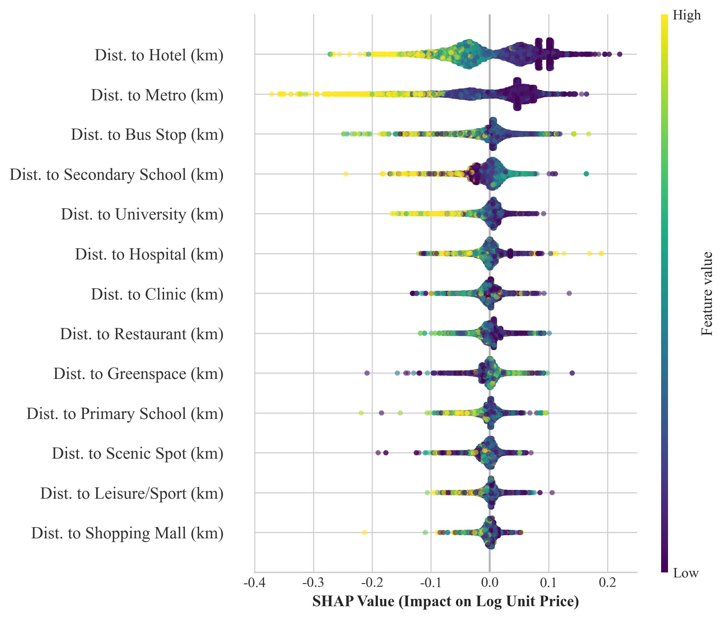
Figure 2. SHAP-based feature importance

  - Distance decay effect of urban amenities on housing pricing
    - Distance to commercial & retail services
Figure 3 illustrates the distance decay effects of key commercial and retail amenities on housing prices. The results reveal pronounced non-linear and amenity-specific capitalization patterns, indicating that housing values are shaped by optimal accessibility within distinct service catchments rather than by simple proximity.
Restaurants and hotels (Panels b and c) exhibit broadly similar distance response patterns, with positive capitalization effects within relatively short walking distances followed by a transition to negative contributions beyond their respective thresholds. For restaurants, the ALE curve remains positive until approximately 0.52 km, whereas hotels maintain positive effects over a much broader range before crossing zero at approximately 2.64 km. These differences reflect their distinct roles within the urban system. Restaurants primarily support neighborhood-level daily consumption and derive value from convenient walking access, resulting in a relatively localized service catchment. Hotels, by contrast, are destination-oriented amenities associated with tourism, business activity, employment concentration, and diversified urban services. Their broader spatial influence therefore reflects the capitalization of urban agglomeration economies extending well beyond the immediate neighborhood.
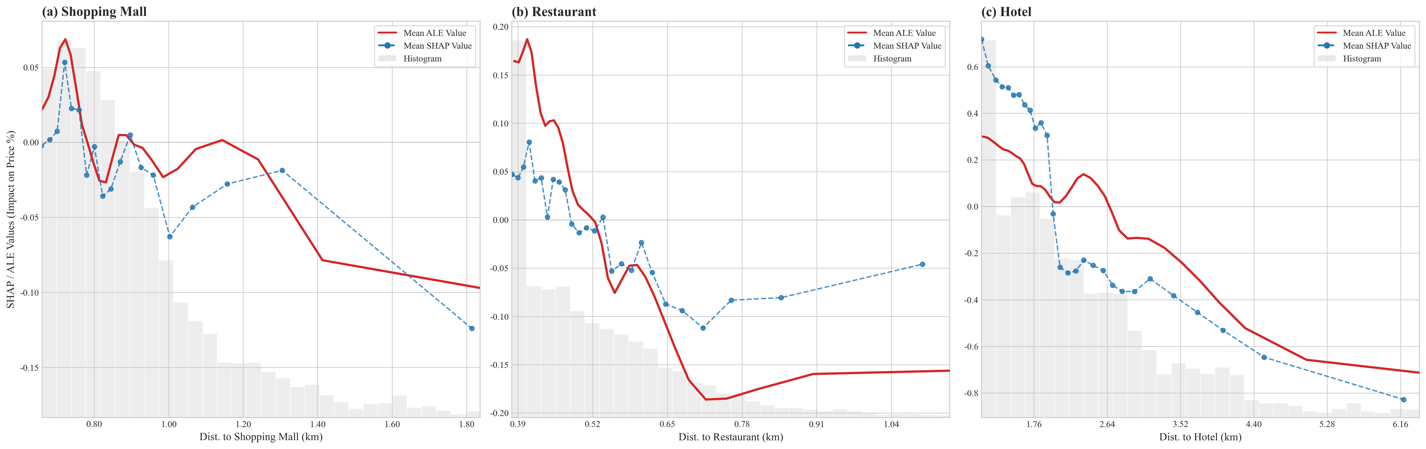
Beyond these optimal accessibility ranges, capitalization effects become progressively negative. As distance increases, households lose the accessibility advantages associated with economically vibrant districts, while tourism-related congestion, noise, crowding, and other localized externalities become relatively more influential. Consequently, the net contribution of proximity declines below zero. These findings are consistent with urban economic theories emphasizing the coexistence of agglomeration economies and localized externalities in dense metropolitan environments and align with previous evidence that the benefits of commercial accessibility diminish with increasing distance (Kholdy et al., 2014; Jang & Kang, 2015; Zhang et al., 2020).

Figure 3. Distance decay effects of commercial & retail services on housing prices
In contrast, shopping malls (Panel a) exhibit a distinct capitalization pattern characterized by a sharp positive premium at very short walking distances, followed by a rapid transition to negative effects. The ALE curve peaks at approximately +0.07 around 0.7 km, then crosses zero at approximately 0.8 km, with only a modest recovery before declining more gradually beyond approximately 0.9 km. This suggests that shopping malls generate their strongest capitalization benefits only within a relatively short walking distance, after which accessibility benefits are quickly outweighed by localized disamenities such as traffic congestion, parking pressures, pedestrian crowding, and commercial noise. Compared with restaurants, shopping malls serve broader catchment areas and support less frequent but higher-order shopping activities. Their capitalization pattern therefore reflects a different balance between accessibility benefits and localized externalities. These findings are consistent with previous studies showing that the capitalization effects of large-scale commercial facilities are non-linear and context-dependent (Kholdy et al., 2014; Zhang et al., 2020; Dou et al., 2023). The close agreement between the SHAP and ALE curves reinforces the robustness of the estimated distance decay relationships, while minor differences reflect local heterogeneity captured by SHAP but smoothed by ALE (Molnar, 2021; Dou et al., 2023).
    - Distance to transport services
Transport accessibility exhibits pronounced non-linear distance decay effects on housing prices, with distinct service catchments across transport modes. As illustrated in Figure 4, both bus stops and metro stations generate positive housing price premiums within their respective accessibility ranges, after which their effects decline and eventually become negative. Rather than sharing a common walking threshold, the two transport modes display markedly different spatial scales of influence, reflecting their complementary roles within Hong Kong's integrated public transport system.
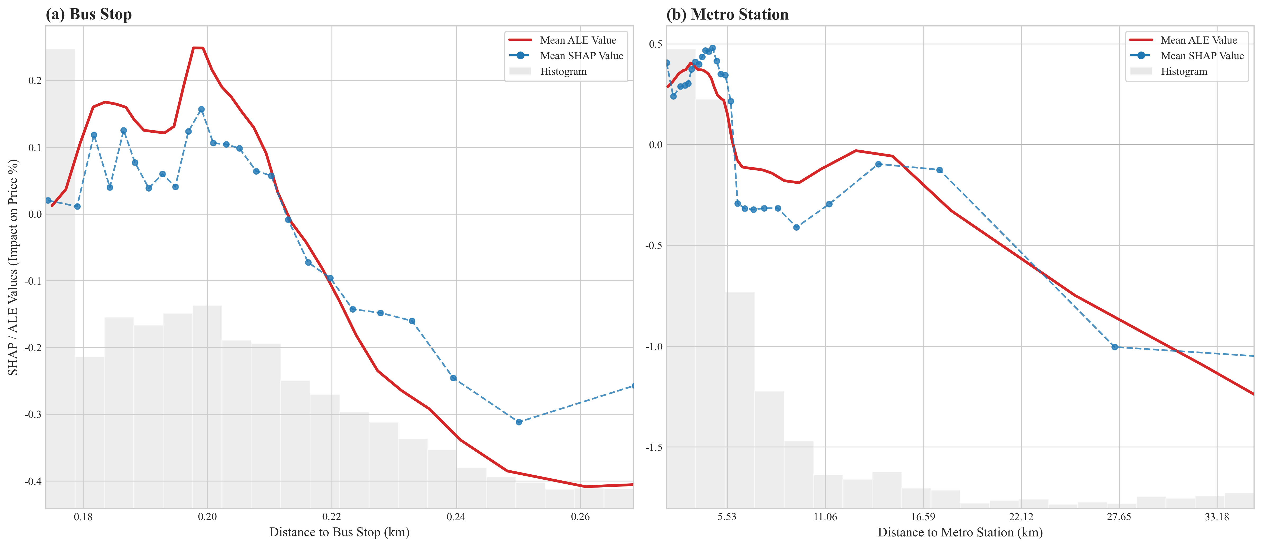

Figure 4. Distance decay effects of transport services on housing prices
Bus stops (Panel a) display a highly localized capitalization pattern. The ALE curve increases from approximately +0.18 at 0.18 km to a peak of nearly +0.26 at 0.2 km, then declines sharply and crosses zero at approximately 0.21 km. Beyond this point, the contribution decreases rapidly to approximately –0.40. This narrow service catchment indicates that the capitalization benefits of bus accessibility are concentrated within very short walking distances, consistent with the role of bus services in supporting neighborhood-level mobility and first-mile/last-mile access to the wider transport network. SHAP values broadly follow the same trend but display greater local dispersion, reflecting neighborhood-level heterogeneity in bus service dependence and surrounding land-use intensity.
Metro stations (Panel b), by contrast, exert a stronger and substantially broader influence on housing prices. The ALE curve reaches a maximum contribution of approximately +0.42 at a network distance of approximately 2.8 km, then declines rapidly and becomes negative at approximately 5.5 km. Beyond this threshold, the capitalization effect remains predominantly negative and gradually weakens with increasing distance. Compared with bus stops, metro accessibility produces considerably larger positive and negative effects, indicating that rail services influence location decisions across much larger spatial scales. This broader service catchment reflects the role of Hong Kong's metro system as the backbone of metropolitan accessibility, connecting residential neighborhoods with major employment centres, commercial districts, and other activity hubs. Although SHAP values exhibit greater variability at intermediate distances, they closely reproduce the overall ALE pattern, indicating substantial neighborhood-level heterogeneity while reinforcing the robustness of the overall distance decay relationship identified by the ALE curve.
Overall, the transport results demonstrate that accessibility premiums are governed by mode-specific service catchments rather than a universal walking threshold. Bus accessibility is highly localized because it primarily supports short neighborhood trips, whereas metro accessibility extends over much broader network distances because rail services provide high-capacity regional connectivity between residential areas and major urban activity centres. These findings further demonstrate that transport accessibility is characterized by amenity-specific, non-linear distance decay relationships rather than uniform accessibility effects, consistent with recent explainable artificial intelligence (XAI) studies (Dou et al., 2023; Lee et al., 2025).
    - Distance to natural and recreational amenities
Figure 5 shows that natural and recreational amenities exhibit pronounced, highly non-linear, and threshold-dependent distance decay effects on housing prices. Across all three amenity types, accessibility premiums are concentrated within relatively short walking distances, indicating that the value of environmental and recreational amenities depends primarily on convenient pedestrian access rather than mere geographic proximity.
For greenspaces (Panel a), the relationship with housing prices is distinctly non-linear. Very close proximity is associated with weak or slightly negative capitalization effects, followed by a sharp increase in housing premiums as walking distance approaches approximately 0.94 km. The ALE curve reaches its maximum between approximately 1.05 and 1.10 km before declining gradually, crossing zero at around 1.50 km and becoming negative thereafter. This pattern suggests that the highest housing premiums are associated with convenient, but not immediate, access to urban greenspaces. While residents value nearby parks for recreation and environmental quality, properties located directly adjacent to greenspaces may also experience localized externalities, such as visitor activity, maintenance operations, and edge effects, which partly offset these benefits. At greater distances, the recreational and environmental advantages become progressively less accessible, leading to declining capitalization effects. These findings are consistent with evidence that the value of urban greenspaces is highly non-linear and context-dependent, with optimal accessibility occurring within a moderate walking distance rather than at the closest possible location (Łaszkiewicz et al., 2022; Z. Liu et al., 2024; Chen et al., 2025; X. Liu et al., 2026).
Scenic spots (Panel b) display a broader service catchment. Housing prices remain positively associated with accessibility until approximately 0.72 km, after which the ALE curve declines sharply and remains negative. Unlike neighborhood parks, scenic attractions are typically visited less frequently and attract users from a wider area, allowing their accessibility benefits to extend across a broader spatial catchment. Nevertheless, once accessibility falls beyond the effective service range, their contribution to housing values diminishes rapidly. Such non-monotonic and context-dependent effects are consistent with recent explainable machine learning evidence highlighting spatial heterogeneity in amenity valuation (Dou et al., 2023; Liu et al., 2026).
Leisure and sport facilities (Panel c) exhibit an intermediate pattern between greenspaces and scenic spots. Positive capitalization effects are maintained within approximately 0.61 km before gradually weakening and becoming negative. Compared with greenspaces, these facilities serve a broader neighborhood catchment because visits are typically planned rather than spontaneous. However, their influence remains more localized than that of scenic attractions, reflecting their role as regular activity-based amenities rather than regional destinations. These findings suggest that the effective service catchment of recreational amenities may not be shaped only by physical accessibility but also by differences in visitation frequency and travel behaviour (Feng & Humphreys, 2012; Keeler et al., 2021; X. Liu et al., 2026).

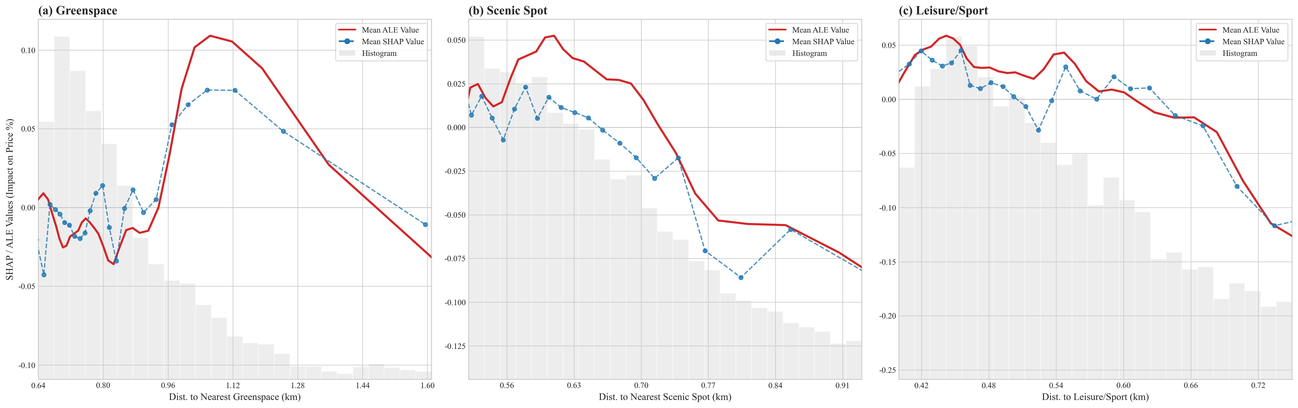
Figure 5. Distance decay effects of natural and recreational amenities on housing prices
    - Distance to healthcare services
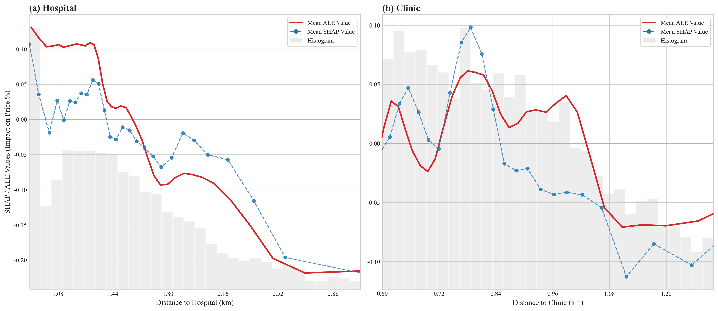
As shown in Figure 6, healthcare accessibility exhibits pronounced non-linear and amenity-specific effects on housing prices. Both hospitals and clinics generate positive capitalization effects within their respective service catchments, followed by a transition to negative effects beyond distinct network-distance thresholds. These findings suggest that housing values are influenced by optimal accessibility to healthcare services rather than simple proximity.

Figure 6. Distance decay effects of healthcare services on housing prices
Hospitals (Panel a) exhibit the strongest and broadest capitalization effect. The ALE curve remains consistently positive over a relatively wide range of walking distances, with values of approximately +0.10 to +0.13 between 1.02 and 1.35 km, before declining sharply. The contribution crosses zero at approximately 1.64 km and becomes increasingly negative thereafter. This pattern suggests that households value convenient access to higher-order healthcare services, while avoiding the immediate vicinity of large hospitals, where ambulance traffic, noise, visitor activity, and other hospital-related externalities may reduce residential desirability. Beyond the optimal accessibility range, the benefits of hospital access diminish as travel costs increase, leading to progressively lower capitalization effects. Similar non-linear relationships have been reported for large healthcare facilities in urban housing markets (Peng & Chiang, 2015; Gu et al., 2024; Lee et al., 2025).
Clinics (Panel b) exhibit a more localized and complex capitalization pattern. Following modest fluctuations at very short distances, the ALE curve rises to a peak of approximately +0.06 around 0.78–0.80 km, and then declines rapidly, becoming negative beyond 1.04 km. Compared with hospitals, primary healthcare services have a smaller magnitude and a narrower service catchment, reflecting their routine nature and widespread spatial distribution throughout Hong Kong. Because clinics are widely distributed, accessibility to them is less differentiated across locations and therefore contributes less to housing price variation. These findings are consistent with previous studies showing that accessibility to primary healthcare services generates relatively modest but highly localized housing price premiums in compact urban environments (Peng, 2021).
Overall, the healthcare results suggest that housing price premiums are shaped not only by accessibility but also by the functional hierarchy of medical services. Higher-order facilities exert broader and more pronounced capitalization effects because they provide specialized services with limited substitutes, whereas the widespread availability of primary care substantially reduces the marginal value of clinic proximity.
    - Distance to educational facilities
Educational facilities exhibit distinct non-linear, stage-specific distance decay effects on housing prices, with substantial differences in both the magnitude and spatial extent of capitalization across education levels. As illustrated in Figure 7, the effects vary considerably across primary schools, secondary schools, and universities, indicating that the capitalization of educational accessibility depends not only on proximity but also on each institution's functional role and service catchment.
Primary schools (Panel a) exhibit a highly non-linear relationship characterized by multiple local peaks and troughs. The ALE curve remains predominantly positive across most of the observed network-distance range and reaches a local maximum of approximately +0.12 near 2.8 km. However, it briefly falls below zero between approximately 2.2 and 2.5 km before recovering to positive values, highlighting localized heterogeneity in the capitalization of primary school accessibility. Beyond approximately 3.2 km, the curve crosses zero permanently and remains negative thereafter. This oscillating pattern suggests that the capitalization of primary school accessibility is influenced by localized factors beyond distance alone, including variation in school quality, school catchment boundaries, neighborhood socioeconomic characteristics, and the spatial distribution of competing schools.
Secondary schools (Panel b) display a broader and more persistent positive effect than primary schools. The ALE curve gradually increases, reaching a maximum of nearly +0.19 at approximately 6.6 km, before declining sharply, crossing zero shortly after 7.3 km, and becoming increasingly negative thereafter. This N-shaped relationship likely reflects Hong Kong's secondary school allocation system, under which households often prioritize access to prestigious schools beyond their immediate neighborhoods, while older students are generally willing and able to travel longer distances than primary school pupils. Consequently, housing price premiums are sustained across intermediate network distances before diminishing as increasing travel costs outweigh the benefits of accessibility.
Universities (Panel c) exhibit the broadest service catchment among the three education categories, maintaining positive capitalization effects across both short and intermediate network distances. The ALE curve reaches a maximum of nearly +0.16 at approximately 1.6 km, remains positive over a relatively wide range, crosses zero at approximately 4.5 km, and subsequently decreases more rapidly. This broad service catchment reflects the regional influence of universities, whose benefits extend beyond surrounding neighborhoods through employment opportunities, knowledge spillovers, research activities, and educational resources. Beyond approximately 4.5 km, however, these capitalization benefits diminish rapidly, leading to declining housing price premiums.
Overall, the results demonstrate that the capitalization of educational accessibility is governed by education-stage-specific distance thresholds rather than a universal proximity effect. More broadly, these findings align with previous research indicating that housing price premiums associated with educational facilities are shaped by the interplay of accessibility, institutional quality, school catchment policies, and household educational preferences, rather than by distance alone (Black, 1999; Gibbons & Machin, 2008; Feng & Lu, 2013; Wen et al., 2019; Lee et al., 2025).

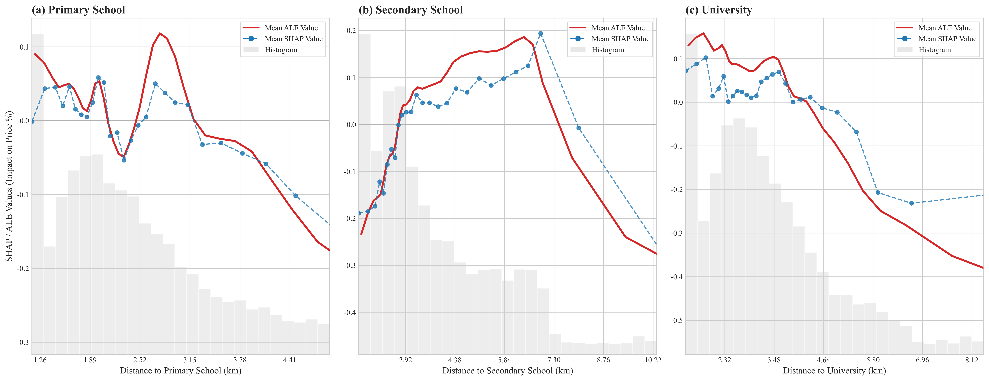
Figure 7. Distance decay effects of education facilities on housing prices
- Conclusions
This study advances understanding of housing price formation by identifying the distance decay effects of urban amenities using explainable machine learning techniques and network-based accessibility measures. By integrating XGBoost with SHAP and ALE on a large-scale dataset of 722,244 property transactions in Hong Kong, the analysis uncovers precise, data-driven functional forms of amenity capitalization in one of the world’s most compact urban environments. Methodologically, this framework combines machine learning with explainable AI tools and pedestrian walking network distance to provide a transparent approach for identifying continuous distance-response functions and amenity-specific thresholds that are difficult to capture using conventional hedonic models. The results demonstrate that the relationship between amenities and housing prices is strongly non-linear, threshold-dependent, and amenity-specific, challenging the conventional assumption that amenity effects decay smoothly or monotonically with distance.
A key empirical contribution is the identification of clear and amenity-specific spatial thresholds based on pedestrian walking network distance. Transport amenities exhibit distinct service catchments, with bus stops generating highly localized premiums that disappear beyond approximately 0.21 km, whereas metro stations remain positively associated with housing prices until approximately 5.5 km. Healthcare facilities also display differentiated thresholds, with the capitalization effects of clinics and hospitals diminishing beyond approximately 1.04 km and 1.64 km, respectively. Commercial and retail amenities exhibit varied service catchments, with restaurants, shopping malls, and hotels turning negative at approximately 0.52 km, 0.9 km, and 2.64 km, respectively. Natural and recreational amenities likewise demonstrate amenity-specific patterns, with greenspaces, leisure and sport facilities, and scenic spots exhibiting thresholds of approximately 1.5 km, 0.61 km, and 0.72 km, respectively. Educational facilities display more complex and stage-specific dynamics, with primary schools, universities, and secondary schools remaining positively associated with housing prices until approximately 3.2 km, 4.5 km, and 7.3 km, respectively. Together, these findings demonstrate that housing prices are shaped by optimal accessibility within amenity-specific service catchments rather than by simple geographic proximity or a universal walking threshold.
Beyond identifying amenity-specific thresholds, the findings reveal that urban amenity capitalization is characterized by distinct turning points rather than gradual distance decay. Across most amenity types, positive effects weaken beyond an optimal accessibility range and eventually turn negative, indicating that accessibility benefits are progressively offset by increasing travel costs and, in some cases, localized externalities associated with intensive urban activity. These threshold-dependent relationships suggest that conventional linear or fixed-band distance specifications may oversimplify the complex spatial processes underlying housing price formation.
The results provide several practical implications for urban planning and policy design. First, urban amenities should be planned according to their functional service catchments rather than a single accessibility standard. The estimated distance thresholds can serve as practical planning benchmarks for facility siting and for evaluating whether existing services are positioned within value-maximizing accessibility ranges. Second, planners should explicitly account for the trade-off between accessibility gains and localized externalities when allocating major transport, healthcare, and commercial facilities. This implies avoiding both excessive clustering, which intensifies congestion and other localized disamenities, and excessive dispersion, which weakens accessibility benefits, thereby supporting more balanced spatial configurations of urban services.
Third, the estimated service catchments provide an empirical basis for accessibility-based planning strategies, including transit-oriented development, land value capture, and infrastructure investment prioritization. In particular, the identified distance thresholds offer practical reference ranges for prioritizing investments and evaluating where additional infrastructure investment is likely to generate the greatest accessibility and housing-value benefits.
More broadly, these findings contribute to ongoing debates on compact-city and "X-minute city" planning by demonstrating that accessibility cannot be represented by a single universal distance or travel-time threshold. Instead, effective accessibility planning should recognize that different urban amenities operate over distinct network-based service catchments that vary according to their functional characteristics and urban context. This supports recent calls for more flexible and context-sensitive accessibility frameworks capable of accommodating spatial heterogeneity across cities and amenity types (Wang et al., 2025; Zhang et al., 2025; Wang et al., 2026).
The following limitations merit acknowledgment. First, the analytical framework does not explicitly model residual spatial dependence or spatial confounding, since SHAP and ALE characterize an already-fitted model rather than modify its underlying specification. Future research could integrate explainable machine learning with spatially explicit models to assess the robustness of the estimated distance thresholds. Second, pooling transactions from 2012 to 2020 within a single time-invariant model means that the estimated thresholds represent average relationships over a period characterized by substantial temporal variation in the property market. Time-varying or period-interacted specifications could therefore provide a useful robustness check. Third, the pooled model accounts for property usage through a categorical control but does not allow amenity effects or distance-response functions to vary across property-market segments. Usage-stratified models could therefore provide an important test of whether amenity capitalization patterns differ systematically across property types.
Overall, this study demonstrates that housing price responses to urban amenities are fundamentally non-linear, amenity-specific, and shaped by network accessibility. By revealing the heterogeneous service catchments through which different amenities influence housing values, the study provides a more nuanced understanding of accessibility capitalization in high-density cities and offers an empirical foundation for evidence-based urban planning.

References
Apley, D. W., & Zhu, J. (2020). Visualizing the effects of predictor variables in black box supervised learning models. Journal of the Royal Statistical Society Series B: Statistical Methodology, 82(4), 1059–1086.
Black, S. E. (1999). Do better schools matter? Parental valuation of elementary education. The Quarterly Journal of Economics, 114(2), 577–599.
Chen, T., & Guestrin, C. (2016). XGBoost: A scalable tree boosting system. In Proceedings of the 22nd ACM SIGKDD International Conference on Knowledge Discovery and Data Mining (pp. 785–794). Association for Computing Machinery.
Chen, Y., Jiao, J., & Farahi, A. (2023). Disparities in affecting factors of housing price: A machine learning approach to the effects of housing status, public transit, and density factors on single-family housing price. Cities, 140, 104432.
Chen, Y., Ye, Y., Liu, X., Yin, C., & Jones, C. A. (2025). Examining the nonlinear and spatial heterogeneity of housing prices in urban Beijing: An application of GeoShapley. Habitat International, 162, 103439.
Dou, M., Gu, Y., & Fan, H. (2023). Incorporating neighborhoods with explainable artificial intelligence for modeling fine-scale housing prices. Applied Geography, 158, 103032.
Feng, H., & Lu, M. (2013). School quality and housing prices: Empirical evidence from a natural experiment in Shanghai, China. Journal of Housing Economics, 22(4), 291-307.
Feng, X., & Humphreys, B. R. (2012). The impact of professional sports facilities on housing values: Evidence from census block group data. City, Culture and Society, 3(3), 189-200.
Fotheringham, A. S., Yang, W., & Kang, W. (2017). Multiscale geographically weighted regression (MGWR). Annals of the American Association of Geographers, 107(6), 1247–1265.
Gibbons, S., & Machin, S. (2008). Valuing school quality, better transport, and lower crime: evidence from house prices. Oxford Review of Economic Policy, 24(1), 99–119.
Gu, Z., Tang, M., Luo, X., & Feng, J. (2024). Examination of the impacts of hospital accessibility on housing prices: Heterogeneity across attributes, space and price quantiles. Journal of Housing and the Built Environment, 39, 179–200.
Huang, B., Wu, B., & Barry, M. (2010). Geographically and temporally weighted regression for modeling spatio-temporal variation in house prices. International Journal of Geographical Information Science, 24(3), 383–401.
Jang, M., & Kang, C.-D. (2015). Retail accessibility and proximity effects on housing prices in Seoul, Korea: A retail type and housing submarket approach. Habitat International, 49, 516-528.
Jim, C. Y., & Chen, W. Y. (2006). Impacts of urban environmental elements on residential housing prices in Guangzhou (China). Landscape and Urban Planning, 78(4), 422-434.
Jin, T., Cheng, L., Liu, Z., Cao, J., Huang, H., & Witlox, F. (2022). Nonlinear public transit accessibility effects on housing prices: Heterogeneity across price segments. Transport Policy, 117, 48-59.
Keeler, Z. T., Stephens, H. M., & Humphreys, B. R. (2021). The amenity value of sports facilities: Evidence from the Staples Center in Los Angeles. Journal of Sports Economics, 22(7), 799–822.
Kholdy, S., Muhtaseb, M., & Yu, W. (2014). Effect of an open-air, mixed-use shopping center on the price of nearby residential properties. Journal of Real Estate Practice and Education, 17(1), 1-18.
Łaszkiewicz, E., Heyman, A., Chen, X., Cimburova, Z., Nowell, M., & Barton, D. N. (2022). Valuing access to urban greenspace using non-linear distance decay in hedonic property pricing. Ecosystem Services, 53, 101394.
Lee, H., Han, H., & Pettit, C. (2025). Capturing the distance decay effect of amenities on housing price using explainable artificial intelligence. Applied Geography, 174, 103486.
Lee, H., Han, H., Pettit, C., Gao, Q., & Shi, V. (2024). Machine learning approach to residential valuation: A convolutional neural network model for geographic variation. The Annals of Regional Science, 72, 579-599.
Lieske, S. N., van den Nouwelant, R., Han, J. H., & Pettit, C. (2019). A novel hedonic price modelling approach for estimating the impact of transportation infrastructure on property prices. Urban Studies, 58(1), 182-202.
Liu, D., Kan, Z., Wang, J., Kwan, M.-P., Song, J., & Wei, J. (2025). Using spatially explicit high-granularity 3D geospatial data for quantifying public transport walking accessibility inequality and vulnerability in the x-minute city. Cities, 166, Article 106245.
Liu, D., Kwan, M.-P., & Wang, J. (2024). Developing the 15-Minute City: A comprehensive assessment of the status in Hong Kong. Travel Behaviour and Society, 34, 100666.
Liu, X., Qiao, R., Wu, Z., Yang, T., Zhang, X., Zhang, X., & Zhu, Z. (2024). Unveiling the spatially varied nonlinear effects of urban built environment on housing prices using an interpretable ensemble learning model. Applied Geography, 173, 103458.
Liu, X., Zhu, L., Wang, Z., Zhang, X., Zhang, X., Chen, Z., & Qiao, R. (2026). The effects of urban green infrastructures on the housing market. Habitat International, 167, 103629.
Liu, Z., Huang, H., Siikamäki, J., & Xu, J. (2024). Area-based hedonic pricing of urban green amenities in Beijing: A spatial piecewise approach. Environmental and Resource Economics, 87, 1223–1248.
Lundberg, S. M., Erion, G. G., & Lee, S. I. (2018). Consistent individualized feature attribution for tree ensembles. arXiv. https://doi.org/10.48550/arXiv.1802.03888
Lundberg, S., & Lee, S. (2017). A unified approach to interpreting model predictions. arXiv. https://arxiv.org/abs/1705.07874
Malpezzi, S. (2002). Hedonic pricing models: A selective and applied review. Housing Economics and Public Policy, 67–89.
Molnar, C. (2021). Interpretable Machine Learning: A Guide for Making Black Box Models Explainable. Lean Publishing.
Páez, A., Long, F., & Farber, S. (2008). Moving Window Approaches for Hedonic Price Estimation: An Empirical Comparison of Modelling Techniques. Urban Studies, 45(8), 1565–1581.
Peng, T. C., & Chiang, Y. H. (2015). The non-linearity of hospitals’ proximity on property prices: Experiences from Taipei, Taiwan. Journal of Property Research, 32(4), 341–361.
Peng, T.-C. (2021). The capitalization of spatial healthcare accessibility into house prices in Taiwan: An application of spatial quantile regression. International Journal of Housing Markets and Analysis, 14(5), 860–893.
Rosen, S. (1974). Hedonic Prices and Implicit Markets: Product Differentiation in Pure Competition. Journal of Political Economy, 82(1), 34–55.
Seo, K., Salon, D., Kuby, & Golub, A. (2019). Hedonic modeling of commercial property values: Distance decay from the links and nodes of rail and highway infrastructure. Transportation, 46, 859–882.
Tang, B.-S., Wong, K. K., Tang, K. S., & Wong, S. W. (2021). Walking accessibility to neighbourhood open space in a multi-level urban environment of Hong Kong. Environment and Planning B: Urban Analytics and City Science, 48(5), 1340–1356.
Wadu Mesthrige, J., & Maqsood, T. (2022). Transport infrastructure, accessibility, and residential property values: evidence from Hong Kong. Built Environment Project and Asset Management, 12(2), 163-179.
Wang, J., Kwan, M.-P., Liu, D., Liu, Y., & Wang, L. (2026). From proximity to equity: Rethinking X-minute-city policies for accessibility equity through a spatial optimization perspective. Journal of Transport Geography, 132, 104581.
Wang, J., Kwan, M.-P., Liu, D., Liu, Y., & Wang, Y. (2025). 15-minute city beyond the urban core: Lessons from the urban-suburban disparity in PCR accessibility within the X-minute framework. Transportation Research Part A: Policy and Practice, 198, 104546.
Wang, J., Kwan, M.-P., Xiu, G., & Deng, F. (2024). A robust method for evaluating the potentials of 15-minute cities: Implications for sustainable urban futures. Geography and Sustainability, 5(4), 597-606.
Wen, H., Xiao, Y., & Hui, E. C. M. (2019). Quantile effect of educational facilities on housing price: Do homebuyers of higher-priced housing pay more for educational resources? Cities, 90, 100-112.
Wen, H., Zhang, Y., & Zhang, L. (2014). Do educational facilities affect housing price? An empirical study in Hangzhou, China. Habitat International, 42, 155-163.
Wu, C., Ren, F., Hu, W., & Du, Q. (2019). Multiscale geographically and temporally weighted regression: Exploring the spatiotemporal determinants of housing prices. International Journal of Geographical Information Science, 33(3), 489–511.
Yuan, F., Wei, Y. D., & Wu, J. (2020). Amenity effects of urban facilities on housing prices in China: Accessibility, scarcity, and urban spaces. Cities, 96, 102433.
Zhang, L., Zhou, J., & Hui, E. C. M. (2020). Which types of shopping malls affect housing prices? From the perspective of spatial accessibility. Habitat International, 96, 102118.
Zhang, S., Hu, Z., Zhen, F., Kong, Y., & Tong, Z. (2025). Assessing the (in)equality of an x-minute city accounting for human mobility patterns. Transportation Research Part A: Policy and Practice, 192, 104354.

Appendix 1: Variance Inflation Factor (VIF) values of explanatory variables
Feature | VIF
Number of living rooms | 4.99
Number of bedrooms | 4.89
Distance to clinic (km) | 4.01
Distance to leisure/sport (km) | 3.67
Distance to restaurant (km) | 3.67
Distance to scenic spot (km) | 3.08
Distance to shopping mall (km) | 2.80
Distance to hospital (km) | 2.53
Distance to primary school (km) | 2.01
Distance to secondary school (km) | 1.82
Distance to university (km) | 1.80
Distance to greenspace/park (km) | 1.71
Distance to hotel (km) | 1.47
Distance to metro station (km) | 1.29
Distance to bus stop (km) | 1.26
Property usage_Industrial | 1.24
Property usage_Office | 1.12
Property usage_Commercial | 1.03
Mean VIF | 2.47

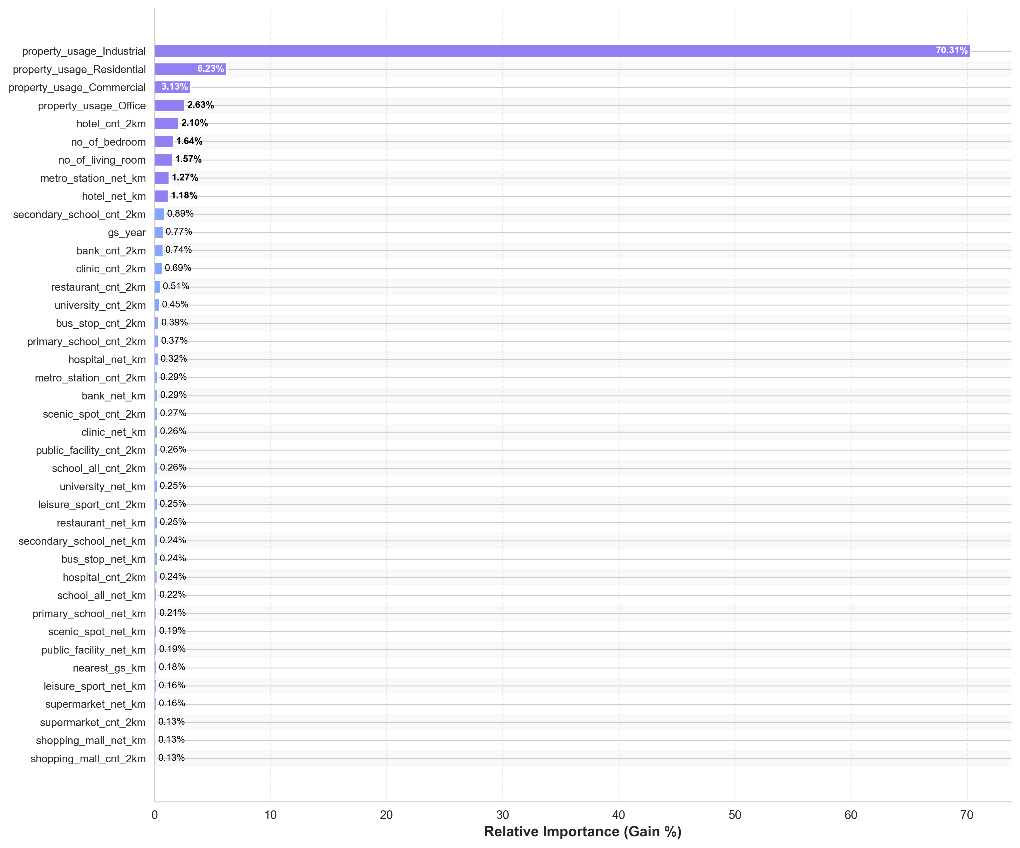
Appendix 2: Global feature importance (XGBoost)

